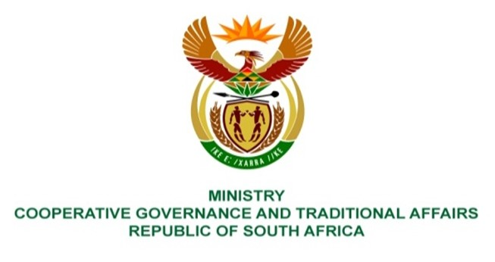

NATIONAL ASSEMBLY
QUESTION FOR WRITTEN REPLY

QUESTION NUMBER 2215
DATE OF PUBLICATION: 03 JUNE 2022

QUESTION:

2215. Mr K Ceza (EFF) to ask the Minister of Cooperative Governance and Traditional Affairs:
With reference to her reply to question 233 on 22 April 2022, what are the details of (a) the report and (b) consequence management of the incident of gender-based violence unleashed by a security company on Councillor Nanziwe Rulashe of Amathole District Municipality? NW2623E

REPLY:

(a) The Executive Mayor, Councillor Ndikinda issued a media statement condemning the assault of the Councilor Rulashe and committed to investigate the matter further. In addition the ADM has been visited by several delegation from Minister of CoGTA and MEC to engage relevant parties affected by the incident. (b) The Executive Mayor requested protection services for Councilor Rulashe from the MEC for Safety and Liaison in the Province. Furthermore, a Threat and Risk Assessemnt report by Crime Intelligence was recieved whereby protection services were commissioned for three months to Councilor Rulashe. The Executive Mayor launched a preliminary report whose findings were reported to Council where it was resolved that an external independant legal firm be commissioned to conduct full investigation and report on its findings. Further steps taken by ADM is that the ADM official responsible for the incident was suspended, secondly a correspondence was made to the Secuirty Company to take disciplinary steps on their employees involved on the incident.

