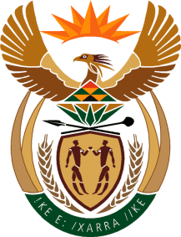

MINISTRY OF TOURISM
REPUBLIC OF SOUTH AFRICA

Private Bag X424, Pretoria, 0001, South Africa. Tel. (+27 12) 444 6780, Fax (+27 12) 444 7027
Private Bag X9154, Cape Town, 8000, South Africa. Tel. (+27 21) 469 5800, Fax: (+27 21) 465 3216

NATIONAL ASSEMBLY:

QUESTION FOR WRITTEN REPLY:
Question Number: 22
Date of Publication: 11 February 2021
NA IQP Number: 1
Date of reply: 23 February 2021

Mr D F Mthenjane (EFF) to ask the Minister of Tourism:
What steps has she taken to ensure that the post-COVID-19 tourism sector is more representative of all the racial groups in the Republic, instead of seemingly being dominated by white persons? NW23E

REPLY:

Government’s transformation policy and in particular the Implementation of the Broad Based Black Economic Empowerment Act is central to the rollout of departmental programmes. Furthermore, the department implements programmes aimed at supporting black people’s participation in ownership, management control, skills development and enterprise development amongst others. The department’s programmes have by design a footprint in the rural areas of our country. The department will continue along this path to ensure that black people are part of the tourism sector post Covid-19 pandemic. Among other interventions on working towards transformation of the sector, we launched the Tourism Equity Fund.

