MINISTER FOR HUMAN SETTLEMENTS: N C MFEKETO, MP DIRECTOR-GENERAL: M S TSHANGANA

NATIONAL ASSEMBLY

QUESTION FOR WRITTEN REPLY QUESTION NUMBER: PQ 2198 (NW2366E) DATE OF PUBLICATION: 8 JUNE 2018

REPLY RECOMMENDED BY:
N CHAINEE
DEPUTY DIRECTOR-GENERAL: STRATEGY AND PLANNING

NATIONAL ASSEMBLY QUESTION FOR WRITTEN REPLY
QUESTION NUMBER: PQ 2198 (NW2366E) DATE OF PUBLICATION: 17 AUGUSY 2018

Mr W M Madisha (Cope) to ask the Minister of Human Settlements:

Whether she has received the report by the Auditor-General regarding the investigation she commissioned into the R80 million investment made by the Community Scheme Ombud Services with VBS Mutual Bank, if not, what is the position in this regards, if so, what (a) are the relevant details of the report and (b) further action has she instituted after receipt of the report?

REPLY:

Upon the matter being drawn to my attention, I directed a letter to the Auditor General to conduct an investigation into the matter of the CSOS investments of its surpluses into financial institutions. The Auditor-General confirmed that it would undertake a regulatory audit as part of the annual audit of the CSOS. The report is still outstanding and once presented will be scrutinised for required steps to be taken should it be found that persons had acted unlawfully, illegally and/or there was fraud, mismanagement, corruption or otherwise.

In addition I have directed that the Director-General taken necessary steps to have a forensic audit carried out as well as consult and ensure that the SIU and/or Hawks are directed to investigate the matter of the CSOS investment of surplus funds in financial institutions.

As and when required I will provide reports to Parliament on the details and progress related to this matter. ›

NATIONAL ASSEMBLY QUESTION FOR WRITTEN REPLY
QUESTION NUMBER: PQ 2198 (NW2366E)

DATE OF PUBLICATION: 17 AUGUST 2018

N CHAINEE
DEPUTY DIRECTOR-GENERAL: STRATEGY AND PLANNING DATE: {. /&

Recommended/not recommended
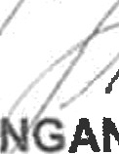
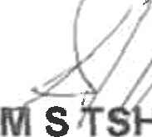
S
A ANA
DIRECTOR-GENERAL

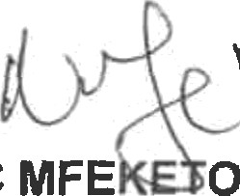
Approved/not approved

N C MFE 0, MI
MINISTER FOR HUMAN SETTLEMENTS DATE:

