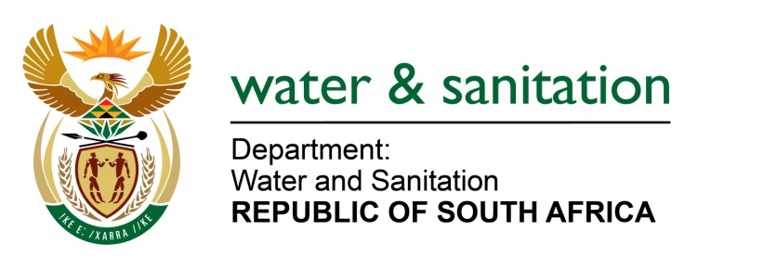

NATIONAL ASSEMBLY

FOR WRITTEN REPLY

QUESTION NO 2194

DATE OF PUBLICATION IN INTERNAL QUESTION PAPER: 14 OCTOBER 2016
(INTERNAL QUESTION PAPER NO. 30)

2194. Ms T E Baker (DA) to ask the Minister of Water and Sanitation:

(a) When will the upgrades of the water treatment works at the (i) Amsterdam and (ii) Sheepmoor Bulk Water Schemes in Mpumalanga commence and (b) what are the (i) budgeted costs and (ii) timeframes in each case? NW2516E
---00O00---

REPLY:

(a) The upgrade of the water treatment works at the Amsterdam and Sheepmoor Bulk Water Schemes in Mpumalanga is anticipated for construction to commence during 2017/18 financial year. The design and implementation readiness study is currently being conducted in 2016/17 financial year.

It should be noted that the Amsterdam and Sheepmoor Bulk Water Shemes are one project.

(b)(i) The budgeted cost for the project is R31 million.

(b)(ii) The duration of the project is for four years, which is 2016/17 to 2019/20 financial years.

---00O00---

