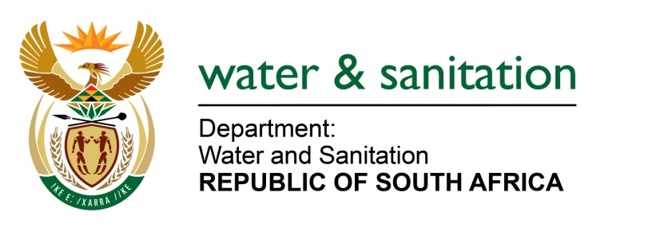

NATIONAL ASSEMBLY

FOR WRITTEN REPLY

QUESTION NO 2193

DATE OF PUBLICATION IN INTERNAL QUESTION PAPER: 14 OCTOBER 2016
(INTERNAL QUESTION PAPER NO. 30)

2193. Ms T E Baker (DA) to ask the Minister of Water and Sanitation:
(1) What (a) is the current status of the Ermelo Waste Water Treatment Plant in Mpumalanga and (b) are the results of the water quality tests of the treated effluent in each month since 1 January 2016;
(2) whether the specified plant complies with the standards for effluent discharge as regulated by her department; if not, what action has she taken to rectify the situation; if so, what are the relevant details? NW2515E
---00O00---
REPLY:

(1)(a) The Ermelo Wastewater Treatment Plant is currently receiving 12-16 Ml/day and is designed to handle 10 Ml/day. Overall, the infrastructure of the plant is in a bad condition and this has compromised the sewage treatment process to the extent that substandard effluent is being discharged.
(b) The Green Drop System, which the Department utilizes to monitor compliance levels of wastewater treatment works in the country, shows that the level of compliance for the plant from 01 January 2016 to September 2016 is zero for micro, physical and chemical parameters specific for wastewater effluent.
(2) The effluent from the plant does not comply with the general standard. The Department had meetings with the municipality, inspections were conducted and correspondence was also sent to the municipality. Due to the lack of response from the municipality, a task team (comprising DWS, the Departments of Human Settlements, Cooperative Governance and Traditional Affairs, Economic Development, Environment and Tourism as well as the District and Local Municipalities) was then established to address the concerns related to the plant. See Tables 1 and 2 below:

Table 1: Correspondence with the Municipality prior to establishment of the task team
DWS Action | Issues raised | Type of communication | Municipality response
Issued communication due to poor water quality discharging into the stream | - sewage pollution  - water use authorisation application | Letter dated 23 November 2009 | None
Site inspection conducted on 14 July 2010 | - sewage pollution | Section 19 letter dated 19 July 2010 | None
Site inspection conducted on 11 Nov 2011 | - sewage pollution at Pet Dam | Meeting held with the  municipality immediately after the inspection | The problem was resolved same day
Site inspection conducted on 14 June 2012 | - sewage spillages and poor effluent quality  - reporting of pollution incidents  - incomplete discharge charges forms  - water use authorisation application  - Poor attendance of stakeholder forum meetings | Meeting with municipality on 06 August 2012 | Raised their challenges

Table 2: Correspondences with the Municipality after establishment of the task team
DWS Action | Issues raised | Type of communication | Municipality response
Issued communication based on the meeting held on 06 August 2012 | - sewage pollution  - establishment of the Task Team | Letter dated 14 August 2012 | None
Follow up | - reminder to respond | Letter dated 11 October 2012 | Submitted insufficient action plan on 14 November 2012
Task Team | Actions from minutes | Meeting on 26 September 2012 at Govan Mbeki Municipality | No feedback, the Municipality sent another person without information
Task Team | Actions from minutes | Meeting on 14 November 2012 at Lekwa Municipality | Attended
Task Team | Actions from minutes | Meeting on 06 February 2013 at Dr Pixley ka Seme Municipality | Did not attend
Issued a communication | - Non-attendance of Task Team meeting | Letter dated 22 February 2013 | None
Task Team | Actions from minutes | Meeting on 12 June 2013 at Gert Sibande District Municipality | Did not attend
Issued a communication | - Action plan | Letter dated 22 August 2013 | None
Assessment of WWTW on 29 October 2013 and 13 March 2014 | - Non-compliance letter | Letter dated 24 March 2014 | None
The Department allocated R 44 275 029 million to refurbish the Ermelo Waste Water Treatment Plant in Mpumalanga. The project commenced in November 2015 and is scheduled for completion in January 2017.

---00O00---

