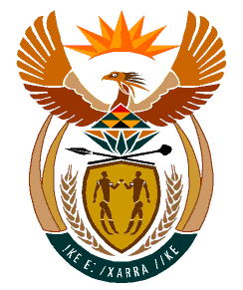

MINISTRY
HUMAN SETTLEMENTS
REPUBLIC OF SOUTH AFRICA

Private Bag X645, Pretoria, 0001. Tel: (012) 421 1309, Fax: (012) 341 8513

Private Bag X9029, Cape Town, 8000. Tel (021) 466 7603, Fax: (021) 466 3610

NATIONAL ASSEMBLY
QUESTION FOR WRITTEN REPLY
QUESTION NUMBER: 2190

DATE OF PUBLICATION: 10 September 2021

DATE OF REPLY: 22 October 2021

2190. Ms E L Powell (DA) to ask the Minister of Human Settlements:

What total amount was spent on the Ministerial event hosted in Duncan Village in the Buffalo City Metropolitan Municipality on 11 March 2021, including (a) logistics, (b) photographers and drone specialists, (c) Ministerial Security, (d) accommodation (e) travel? NW2397E

REPLY

What total amount was spent on the Ministerial event hosted in Duncan Village in the Buffalo City Metropolitan Municipality on 11 March 2021, including:

- Logistics – The Department of Human Settlements spent R0.00

The Housing Development Agency was the event organiser and responsible for all logistical arrangements on 11 March 2021 in Duncan Village.
Accommodation (x 12 staff 2/3 nights) | R50 400,00
Flights (x 11 staff) | R32 368,05
Car Rental (x1) | R3 602,65
Shuttles (x 6 staff) | R7 550,00
Tent Hire & Chairs for 200 Pax  Lunch & Water for 250 Pax  P.A System | R92 120,75
Travel Agency Service Fees | R615,00
TOTAL | R186,650-45

- Photographers and drone specialists – The Department of Human Settlements spent R0.00.

The Department of Human Settlements together with the Department of Water and Sanitation deployed internal photographers – staff members.

- Ministerial Security – One staff member from the Security Unit of the Department of Human Settlements was deployed to the event.

- Accommodation and Travel – Thirteen members of the Department and Ministry travelled to BCM at total amount of R181 915.00

