FOR WRITTEN REPLY

QUESTION 219

NATIONAL ASSEMBLY
36/1/4/1(201900026)

DATE OF PUBLICATION IN INTERNAL QUESTION PAPER: 15 FEBRUARY 2019 (INTERNAL QUESTION PAPER NO 2-2019)

219. Mr D J Stubbe (DA) to ask the Minieter of Police:

- What number of (a) murders were reported at the Norkem Park Police Station in the (i) 2015-16, (ii) 2016-17 and (iii) 2017-18 financial years and (b) the specified murders resulted in a successful conviction;

- what number of (a) women and (b) children were murder victims?

REPLY:

NW229E

(1)(a) The number of murders, which were reported at the Norkem Park Police Station, is as follows:

2015/2016 | 2016/2017 | 2017/2018
 | 11 | e

(1)(b) The number of murders, which resulted in successful convictions, is as follows:

2015/2016 |  | 2016/2017 |  | 2017/2018
CAS  Number | Conviction | CAS  Number | Conviction | CAS  Number | Conviction
222/02/2015 | Life imprisonment | 158/05/2016 | Found guilty  and declared a patient of the State. | None | Not applicable
(2)(a)(b) The number of women and children, who were murder victims, is as follows:

2015/2016 |  | 2016/2017 |  | 2017/2018
Women | Children | Women | Children | Women | Children
3 | 0 | 2 | 0 | 4 | 0

2

Reply to question 219 recommended/

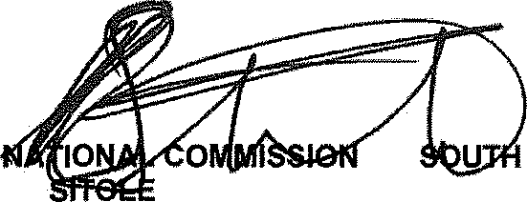
GENERAL AFRICAN POLICE SERVICE
ER:
KJ
(SOEG)

Date: 2fifg -gj- j $
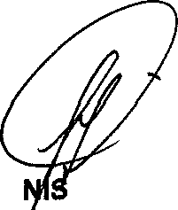
Reply to question 219 approved/

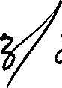
MI TER OF POLICE BH’CELE, MP

Date: @
/

