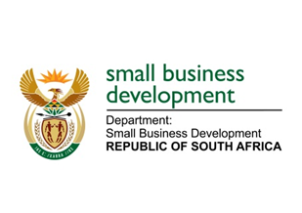
NATIONAL ASSEMBLY
QUESTION FOR WRITTEN REPLY
DUE IN PARLIAMENT: 17 JUNE 2022

2186. Mr J N de Villiers (DA) to ask the Minister of Small Business Development:
Whether, in light of the rising fuel prices and the devastating effect it has on small business, she will consider a Petrol Relief Support Scheme Programme for small-, medium- and micro-enterprises that cannot afford the rising cost of petrol; if not, what is the position in this regard; if so, (a) by what date will it be implemented and (b) what are the further relevant details? NW2592E

REPLY:

The Minister of Small Business Development is aware of the effects of the rising costs of fuel to small enterprises. However, the Minister has not considered further mechanisms to cushion the blow that small enterprises may have felt beyond the government fuel levy relief declared by government. The Minister of Finance announced that the general fuel levy would be temporarily reduced by R1.50 per litre from 6 April 2022 until 31 May 2022. The date of April has since been reviewed to end in August 2022 to provide relief. I believe that the Ministers of Finance and of Mineral Resources and Energy are handling the matter related to fuel relief.

STELLA NDABENI-ABRAHAMS
MINISTER: SMALL BUSINESS DEVELOPMENT

