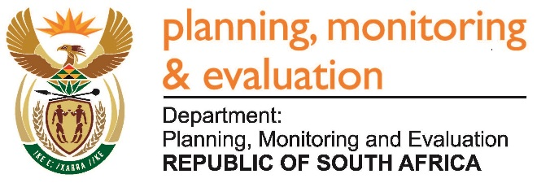
Private Bag X944, PRETORIA, 0001. Union Buildings East Wing, Government Avenue, PRETORIA
Tel: 012 312 0307. www.dpme.gov.za

[No 30—2016] THIRD SESSION, FIFTH PARLIAMENT
______________________

2181. Mr S C Motau (DA) to ask the Minister in The Presidency:

(a) What is the (i) annual retainer and (ii) daily meeting fee paid to each National Planning Commission (NPC) commissioner, (b) how many times a year does the NPC meet and (c) what are the conditions of service of the specified commissioners? NW2503E
Reply:
The Annual Retainer (AR) for the Deputy Chair of the National Planning Commission is R 96 900 and for other Commissioners R86 700. Daily Meeting Fee for the performance of work related to the National Planning Commission by Commissioners is broken down into four categories as follows:
Rates  Description | Purpose | Amount  R
Category A | Deputy Chair – for time taken to prepare for, and attend full plenary meetings | 9 500
Category B | Commissioners - for time taken to prepare for, and attend full plenary meetings | 8 500
Category C | Deputy Chair - for time taken to prepare for, and attend half-day meetings (Working Group/Task Team meetings) | 4 750
Category D | Commissioners - for time taken to prepare for, and attend half-day meetings (Working Group/Task Team meetings) | 4 250

The National Planning Commission usually meets once a month, however, additional meetings may be held depending on need. Commissioners also attend Task Team meetings whose output is refined in the Work Streams in preparation for discussion in the NPC Plenary. These are held depending on need as per each’s work programme of action.
The Conditions of Service of the Commissioners is primarily, to advise the President, Government and the rest of the country on all matters relating to the long-term development of the country.

