MINISTRY OF ENERGY
REPUBLIC OF SOUTH AFRICA

PRIVATE BAG x 96, PRETORIA, 0001, Tel (012) 406 7658
PRIVATE BAG x 9111, CAPE TOWN, 8000 (021) 469 6412, Fax (021) 465 5980
2180. Mr P G Moteka (EFF) to ask the Minister of Energy:

What number of jobs will be created at each Independent Power Producer company which had its bid approved by his department? NW2341E

Reply:

Therefore, job numbers are reported in aggregate. Only the Renewable Energy Power Producer Procurement Programme (REIPPPP) has commenced with construction and operation of IPP projects. Under the REIPPP Programme a total number of 112 projects have been procured and it is envisaged that these projects will create 114 266 job years over the construction and 20 year operations period. A job year is equivalent to a full time employment opportunity for one person for one year.

Table 1: Projects procured: jobs committed during construction and 20 years of operations
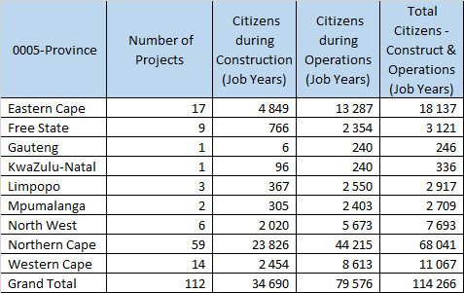
Approved / Not Approved

Mr J T Radebe, MP
Minister of Energy
Date:

