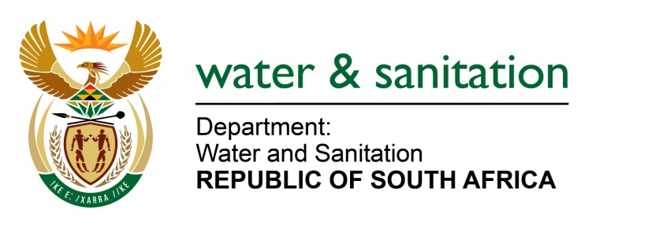

NATIONAL ASSEMBLY

FOR WRITTEN REPLY

QUESTION NO 2177

DATE OF PUBLICATION IN INTERNAL QUESTION PAPER: 07 AUGUST 2017
(INTERNAL QUESTION PAPER NO. 25)
2177. Ms T E Baker (DA) to ask the Minister of Water and Sanitation:
Whether the report of the Motau Task Team that was set up by her to investigate procurement irregularities has been finalised; if not, (a) why not and (b) on what date is it expected to be finalised; if so, will she furnish Ms T E Baker with a copy of the specified report? NW2409E
---00O00---
REPLY:

Requesting Honorable Member to refer to the response provided in NA 1666 of 9 June 2017.
---00O00---

