

**MINISTRY**

**STATE SECURITY**

**REPUBLIC OF SOUTH AFRICA**

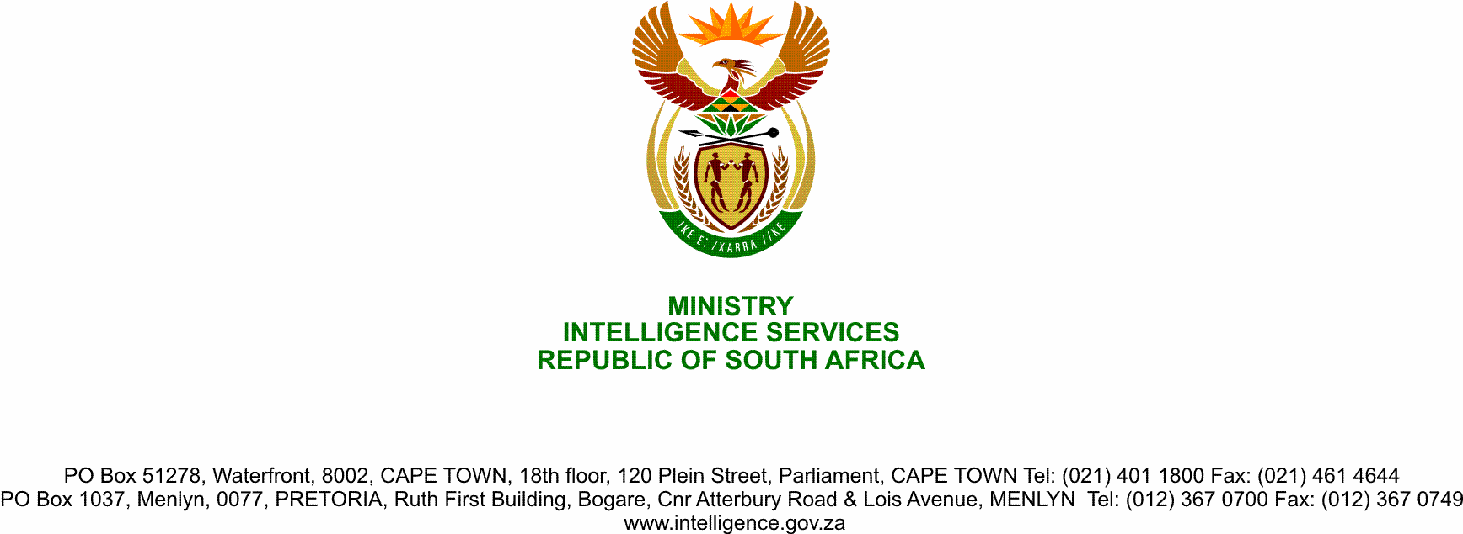

**NATIONAL ASSEMBLY**

**QUESTION FOR WRITTEN REPLY**

**QUESTION NO.:** **2174.**

**Ms T L Marawu (ATM) to ask the Minister of State Security:**

Whether, based on Mr Edwin Sodi’s recent testimony at the Judicial Commission of Inquiry into Allegations of State Capture, Corruption and Fraud in the Public Sector including Organs of State, which implicated her Deputy Minister as a beneficiary of Mr Sodi’s company, her Deputy Minister declared the funds he had received in accordance with the requirements of the Executive Members’ Ethics Act, Act 82 of 1998, to the Registrar of Members’ Interest in Parliament; if not, what (a) total number of contracts have been awarded to Mr Sodi’s company under his leadership in his current executive position and (b) is the monetary value of each specified contract so awarded? NW2737E

**REPLY**

The Deputy Minister has submitted a Reply in this regard to the Parliament Office of the African Transformation Movement (ATM)