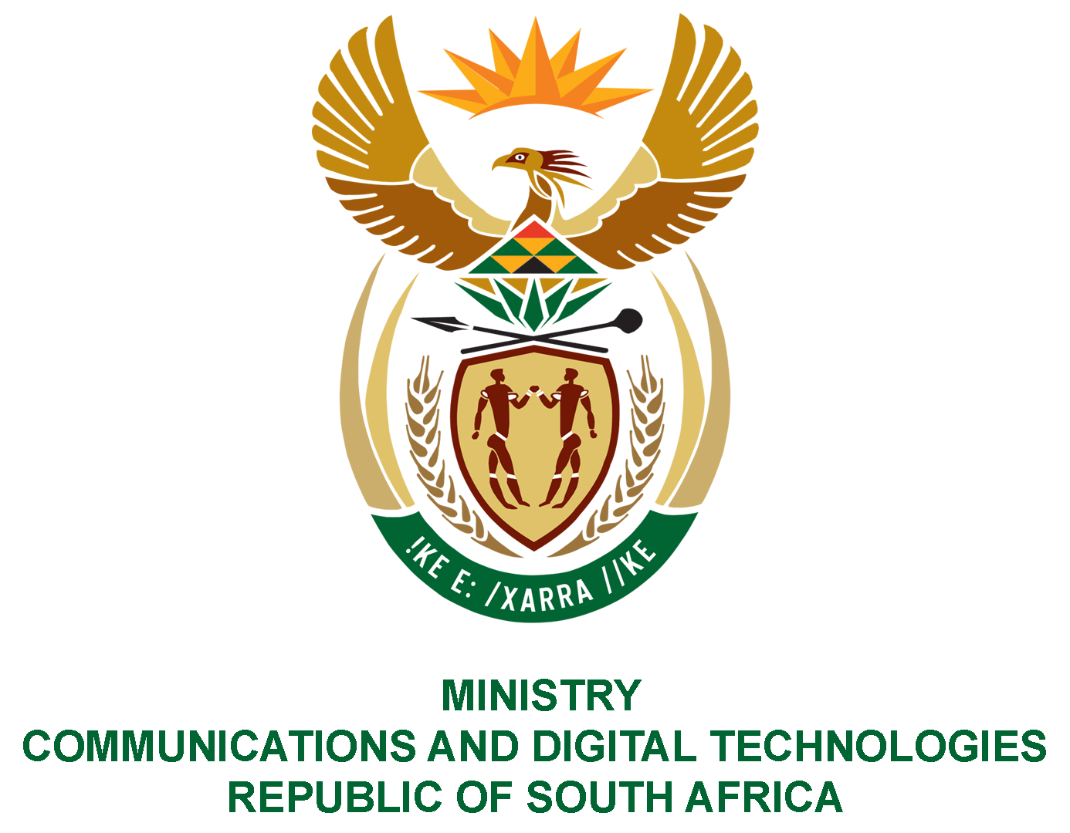
PARLIAMENT OF THE REPUBLIC OF SOUTH AFRICA
NATIONAL ASSEMBLY
WRITTEN REPLY
QUESTION NO: 2173
DATE OF PUBLICATION: 9 October 2020
QUESTION PAPER NO: 36
Ms T L Marawu (ATM) to ask the Minister of Communications:
Whether, based on Mr Edwin Sodi’s recent testimony at the Judicial Commission of Inquiry into Allegations of State Capture, Corruption and Fraud in the Public Sector including Organs of State, which implicated her Deputy Minister as a beneficiary of Mr Sodi’s company, her Deputy Minister declared the funds she had received in accordance with the requirements of the Executive Members’ Ethics Act, Act 82 of 1998, to the Registrar of Members’ Interests in Parliament; if not, what (a) total number of contracts have been awarded to Mr Sodi’s company under her leadership in her (i) previous and (ii) current executive position and (b) is the monetary value of each specified contract so awarded?
NW2736E
REPLY:
I have been advised by the Deputy Minister as follows:

- No payments were made in the current financial year as well as in the previous financial years.

- Not applicable.

MS. STELLA NDABENI-ABRAHAMS, MP
MINISTER OF COMMUNICATIONS AND DIGITAL TECHNOLOGIES

