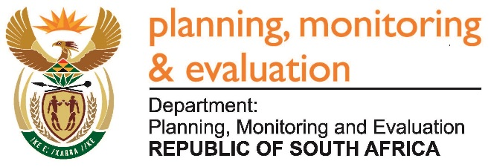 |  | 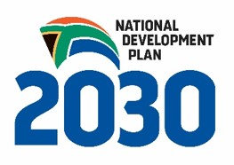
Private Bag X944, PRETORIA, 0001. Union Buildings East Wing, Government Avenue, PRETORIA
Tel: 012 312 0307. www.dpme.gov.za

[No 30—2016] THIRD SESSION, FIFTH PARLIAMENT
______________________
NATIONAL ASSEMBLY

2172. The Leader of the Opposition (DA) to ask the Minister in The Presidency:

What was the total financial cost to the State for all litigation involving the non-security upgrades at the President, Mr Jacob G Zuma’s, private homestead in Nkandla in KwaZulu-Natal? NW2493E

REPLY:

The Presidency Annual Report (2015-2016) with the Financial Statements, was tabled in Parliament on 29 September 2016. The financial statements that are prepared by the accounting officer, are prepared in accordance with Modified Cash Standards prescribed by National Treasury and the requirement of Public Finance Management Act (Act No. 1 of 1999). The financial statements allow the grouping of some transactions and therefore do not allow for identification of transactions that can be related to this question.

