rOR WRITTEN REPLY
I
QUESTION 2170

NATIONAL ASSEMBLY
36/1/4/1(201800207} - ! :

DATE OF PUBLICATION IN II4TERNAL QUESTION PAPER: 16 JUNE 2018 . fINTERNAL QUESTION PAPER NO 21-2018) ’
2170. Mr S P Mhlongo (EFS) to aekthe Minister of Police:

What is the current (i) total number and (ii) type of police vehicles (aa) at each polfce station and [bb) in aaeh province in the country's
NW2327E
REPLY: ' '
.... (i) The tota( number of active Sovtfi African Pollcs Sorvlee (sAPS) vehicles, on
18 June 2018, was 47 600.
(1) TheQpeeofvehiclss,ereagfo)owo: '
-+ Autonobile9 - Vehicles, which are referred to as sadans. !
Buses — Vehldes with a seating capacity of more than 16, .
w Light commercial vehicles — Commonly known ae police vana/bakkies. ,
-+ Minlbuses — Vehicles with a seating capacity of less than 16 persons. :

—+ Multi•purposa vehicles.
PaneJvans. -

--› Sport Utility Vehicles (SUVs).
-+ Trucks.
(aa) This information is reflected In Annexure A.

..' (bb) The total number of SAPS vehi0lee, as at 16 June 2018, In eaoh roVihce and ) at the divisions at national level, 1s as follows:

.
 | Total.Véhialea
h6Starn Ca§0 | 5036
Frea State | 3243 ” ”
Gauteng | 8 085
Haad Office
KwaZuU-Natal | 8 984
Llmpopo | 3 075
M#uinalan a | 2 581
North Weet | 2 885
Noitharn Cage | 2 186
Weeteff\ Gape | 8 09Y
Gratid"Totaf | ”47" | 590

. :
”
'
-

T

-

Reply to question 2170 r86OMITIended/

L COMtl4lSSlONER: SDUTH AFRICAN POLICE 8ERVtCE

LE (SOEG)
Date: @ --- @@ •
Reply to ques#on 21Y0 approved/
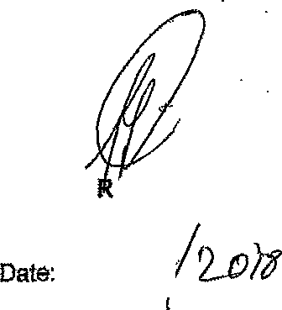

MIKISTE OF POLICE BH CELE, £fP

