36/1/4/1(201900028)
NATIONAL ASSEMBLY

FOR WRITTEN REPLY
QUESTION 217
DATE OF PUBLICATION IN INTERNAL QUESTION PAPER: 15 FEBRUARY 2016 (INTERNAL QUESTION PAPER NO 2-2019)

217. Mr M Bargraim (DA) to ask the Minister of Police:

- What number of (a) murders were reported at the Tembisa South Police Station in the (i) 2015-16, (ii) 2016-17 and (iii) 2017-18 financial years and (b) the specified murders resulted in a successful conviction;

- what number of (a) women and (b) children were murder victims?

REPLY:

NW227E

(1)(a) The number of murders, which were reported at the lembisa South Police Station, is as follows:
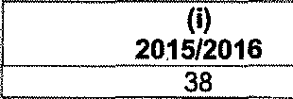
(i)
2015/2016
38
(li)
..2. 0.1..6.../.2..0...1..7.....-.. ................
43
2017/2018
50

(1)(b) The number of murders, which resulted in successful convictions, is as follows:

2015/2016 |  | 2016/2017 |  | 2017/2018
CAS  Number | Conviction | CAS  Number | Conviction | CAS  Number | Conviction
174/03/2015 | 33 years  imprisonment | 38/03/2016 | 18 years  imprisonment | 138/06/2017 | 3 years imprisonment
90/07/2015 | 19 years  imprisonment | 06/11/2016 | 6 years  imprisonment
102/11/2015 | 5 years  imprisonment | 59/05/2016 | 15 years  imprisonment
278/07/2015 | 5 years  imprisonment | 04/08/2016 | 20 years  imprisonment
(2)(a)(b) The number of women and children, who were murder victims, is as follows:
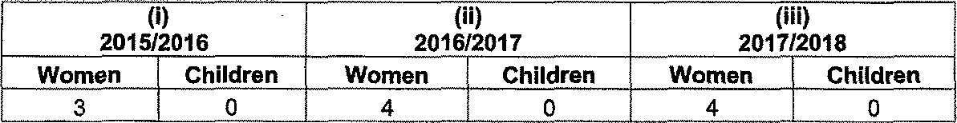
2015/2016
2016/2017
2017/2018
Women Children Women Children Women Children
3 0 4 0 4 0

Reply to question 217 recommended/

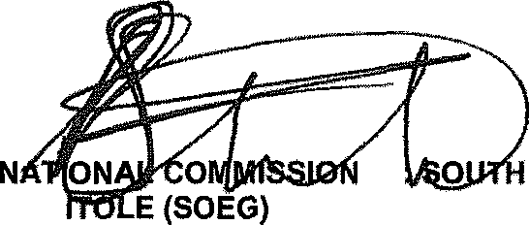
GENERAL AFRICAN POLICE SERVICE
ER
KJ S

Reply to question 217 approved/

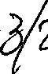
MINISTE F POLICE BH CELE, MP
@

Date: /

