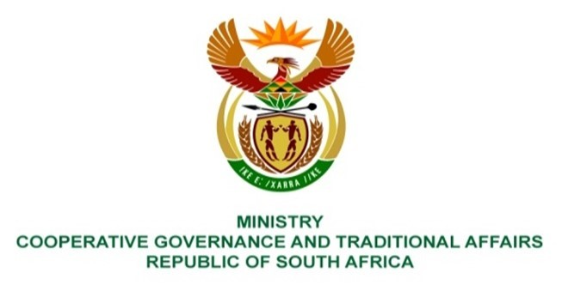
NATIONAL ASSEMBLY
QUESTIONS FOR WRITTEN REPLY
QUESTION NUMBER 2164
DATE OF PUBLICATION: 27th August 2021
QUESTION:
2164. Mrs S M Mokgotho (EFF) to ask the Minister of Cooperative Governance and Traditional Affairs:
(1) On what date is it envisaged that her department will deliver water to the Lerome South community in Moses Kotane Local Municipality, since their taps have run dry?
NW
REPLY:
The municipality does not have sufficient bulk water infrastructure to meet the demand of the growing area. To that end it is currently supplying water through interim measures of water carting to temporal storages including water tanks which are then utilized by the community of Lerome South. These are interim measures put in place while the municipality works on a permanent solution.

Moses Kotane Local Municipality (MKLM) is a Water Services Authority (WSA) in the MKLM area of jurisdiction which includes Lerome South. The Water Services Act, 108 of 1997 defines a WSA as any municipality responsible for ensuring access to water services. In executing its functions, which include the WSA function, MKLM gets grant funding and technical support from the provincial and national government departments.
MKLM is implementing a bulk water supply project (bulk water line and reservoir) scheduled to complete by end of November 2021. The bulk water supply project is funded thorough the Water Services Infrastructure Grant (WSIG) administered by the Department of Water and Sanitation (DWS).

MKLM indicated that it has prioritised in this financial year Municipal Infrastructure Grant (MIG) Implementation Plan a project, among others, for water reticulation for Lerome South. In an effort to avoid misalignment between bulk and reticulation, the reticulation project is only under consideration this financial year when the WSIG funded bulk project is near completion. The DWS, as the responsible sector department, is currently appraising the technical report submitted by MKLM for water reticulation through the MIG funding. The MIG funding is administered by the Department of Corporative Governance (DCOG). DCOG through the Municipal Infrastructure Support Agent (MISA) is providing technical support to MKLM for both project implementation and the MIG funding application.

The estimated date to deliver the full functional water supply project to Lerome South, having completed both the WSIG funded bulk water and MIG funded water reticulation projects, is anticipated to be in November 2022.

