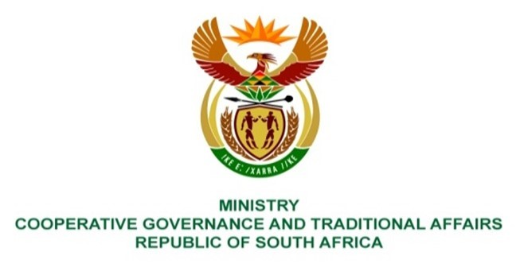

NATIONAL ASSEMBLY
QUESTIONS FOR WRITTEN REPLY
QUESTION NUMBER 2163 DATE OF PUBLICATION: 03 September 2021
QUESTION:
Water Challenges in Maluti A Phofung Local Municipality
2163. Mrs S M Mokgotho (EFF) to ask the Minister of Cooperative Governance and Traditional Affairs:
What interventions have been put in place by her department to ensure that the community of Ward 7, 8, 9 and 10 in QwaQwa in the Thabo Mofutsanyane District Municipality have water on a daily basis amidst the water shortage in that area?
NW2453E
REPLY:
- According to the Maluti-a-Phofung (MAP) Local Municipality the water situation in the municipality has improved significantly from last year. The major cause of water problems in QwaQwa was the drought. Following the recent rains, the main Fika Patso dam supplying QwaQwa is now at 75% full capacity. The other major problem is old infrastructure being mainly AC pipes that are constantly bursting causing intermittent cuts in water supply.
- In accordance with the District Development Model (DDM) that ensures integrated service delivery by government and non-government stakeholders, the Department of Cooperative Governance and Traditional Affairs (COGTA) through the Municipal Infrastructure Support Agent (MISA) is supporting Maluti-A-Phofung (MAP) Local Municipality to monitor interventions and the implementation of projects aimed at proving electricity among other services.
- According to MAP Local Municipality, the interventions and projects mentioned above include the following:.
i. In the wards in question the MAP Local Municipality is undertaking repairs to burst pipes, which are common in all wards due to aged infrastructure. ii. MISA supported the Municipality to develop a Water Conservation and Demand Management Plan and to draft a Water O&M plan to improve the operations and maintenance regimes for all wards in MAP Local Municipality. iii. In ward 10, Tseki area some 2 boreholes were drilled and equipped with solar pumps, 5 000 litre tanks and stand pipes and security fencing with funding from DBSA in partnership with MISA (as part of the COVID-19 interventions) for a total cost of R762 427,78. These were handed over to the community.
- COGTA, with provincial counterparts and MISA, led a rigorous process of assessing the state of local government (SOLG). The assessment included all service delivery issues including the provision of electricity in MAP. A process is underway to address basic service delivery issues and the target date to complete the municipal intervention and support plans (MISP) for high priority municipalities like MAP is the end of September 2021. This MISP will include plans to address the water challenges mentioned above.
- The compilation of MISP brings together all sector departments as advocated for by the DDM.

