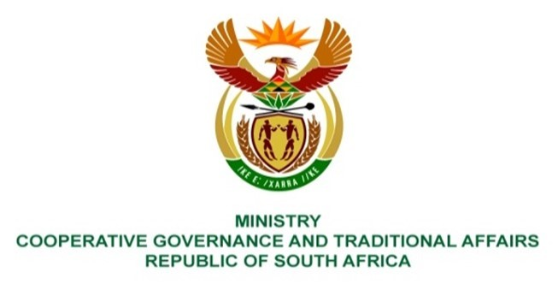
NATIONAL ASSEMBLY
QUESTIONS FOR WRITTEN REPLY
QUESTION NUMBER 2161 DATE OF PUBLICATION: 03 SEP 2021
QUESTION:
2161. Mr K Ceza (EFF) to ask the Minister of Cooperative Governance and Traditional Affairs:
QUESTION:
What interventions has she made to assess the incapacity of the City of Cape Town and Western Cape provincial government to resolve flooding, which occurs during rainy seasons as a result of wrongfully planned drainage systems in areas like Khayelitsha, Gugulethu, KwaLanga and in all informal settlements?
NW2451E
REPLY:
A rigorous process of assessing the state of local government (SOLG) culminated in the Cabinet considering the SOLG report in June 2021. The assessment included all service delivery issues including drainage systems in the City of Cape Town (CoCT). Cabinet resolved that the Department of Cooperative Governance and Traditional Affairs (COGTA) and National Treasury should lead the process of the development of the municipal support plans in collaboration with sector departments, SALGA, provinces and municipalities. This process is underway and the target date to complete the municipal intervention and support plans (MISP) is the end of October 2021. This MISP will include plans to address the challenges mentioned above.
As stated above, the compilation of MISP brings together all sector departments as advocated for by the District Development Model as service delivery challenges of informal settlements go beyond flooding challenges, but include lack of basic services and housing among others.
We are also planning to brief the nation on the 21 October 2021 on the seasonal weather forecast. This briefing will include the state of readiness in municipalities across provinces to deal with disasters resulting from the seasonal rainfall.

