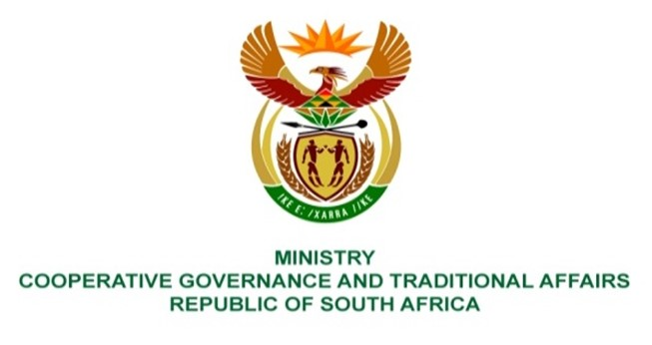

NATIONAL ASSEMBLY
QUESTIONS FOR WRITTEN REPLY

QUESTION NUMBER 2160
DATE OF PUBLICATION: 03 September 2021

QUESTION:
2160. Mr K Ceza (EFF) to ask the Minister of Cooperative Governance and Traditional Affairs:

What are the reasons that her department has not been providing relief to 123 villages that
are currently without water in Peddie under the Amathole District Municipality? NW2450E

REPLY:
Amatole District Municipality (ADM) is the Water Services Authority (WSA) in the ADM area of jurisdiction which includes Peddie. The Water Services Act, 108 of 1997 defines a WSA as any municipality responsible for ensuring access to water services. ADM however gets grant funding and technical support from the provincial and national government departments.

According to ADM, the water infrastructure in the villages in Peddie is not operating as designed to provide basic water through standpipes because of rampant illegal yard and house connections in about 80 % of the villages. This causes pressure reduction and higher water demand resulting in no water or intermittent supply to about 23 of the 123 villages. ADM supplements supply with water tankers that deliver water to communities.

Furthermore, ADM is implementing a multi-year Municipal Infrastructure Grant (MIG) funded project, Ngqushwa Villages Water Reticulation for about R36 million scheduled for completion in January 2022. ADM is conducting community awareness programmes highlighting the negative impact of illegal connections.

