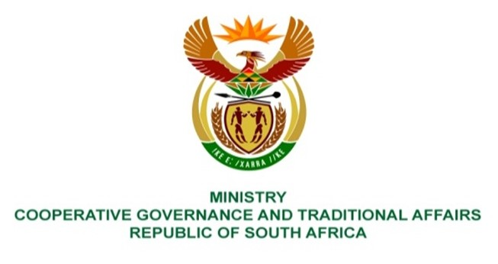

NATIONAL ASSEMBLY
QUESTIONS FOR WRITTEN REPLY

QUESTION NUMBER: 216
DATE OF PUBLICATION: 17 FEBRUARY 2023

216. Mr I M Groenewald (FF Plus) to ask the Minister of Cooperative Governance and Traditional Affairs:
(1) Whether, in light of section 121 of the Municipal Finance Management Act, Act 56 of 2003 (MFMA) requiring all municipalities to table their annual reports to their respective municipal councils by 31 January every year, or request an extension from their provincial Members of the Executive Council (MECs); she and/or her department must be provided with reports of any municipalities that failed to table their reports by 31 January 2023; if not, what is the position in this regard; if so, (a) which municipalities failed to table their reports, (b) what were the reasons for non-compliance, (c) did the specified municipalities timeously apply for extensions to the respective MECs and (d) which municipalities that failed to table their reports by 31 January, also failed to apply for extensions to their respective MEC’s;
(2) whether she will make a statement on the matter? NW220E

REPLY:
The information required by the Honourable Member is not within the purview of the Departments of Cooperative Governance and/or Traditional Affairs but that of Department of Finance.

It is recommended that this question be directed to the Minister of Finance.

