FOR WRITTEN REPLY QUESTION 216

NATIONAL ASSEMBLY
36/1/4/1(201900029)

DATE OF PUBLICATION IN INTERNAL QUESTION PAPER: 15 FEBRUARY 2019 (INTERNAL QUESTION PAPER NO 2-2019)

216. Mr M Bargraim (DA) to ask the Minister of Police:

- What number of (a) murders were reported at the Sebenza Police Station in the (i) 2015-16, (ii) 2016-17 and (iii) 2017-18 financial years and (b) the specified murders resulted in a successful conviction;

- what number of(a) women and (b) children were murder victims’?

REPLY:

NW226E

(1)(a) The number of murders, which were reported at the Sebenza Police Station. is as follows:
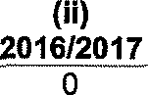
2017/2018
5
(i)
2015/2016
7
”

(1)(b) The number of murders, which resulted in successful convictions, is as follows:

CAS
2015/2016
Conviction

CAS
2016/2017

Conviction

CAS
2017/2018
Conviction

Number
219/05/2015

25 years im risonment
Number
None

Not
a licable
Number
None
Not
a plicable

(2)(a)(b) The number of women and children, who were murder victims, is as follows:
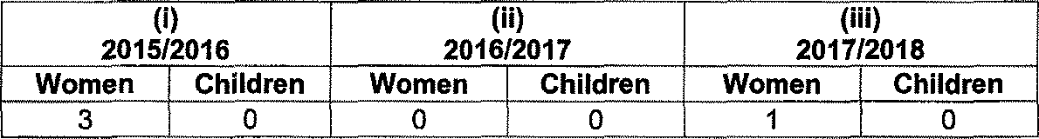
2015/2016
2016/2017
2017/2018
Women Children Women Children Women Children 3 0 0 0 1 0

Reply to question 216 recommended

COM LE (SOEG

Date: " ” ” '

ER:
GENERAL
AFRICAN POLICE SERVICE

Reply to question 216 approved/medo

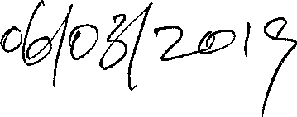
MINIS OF POLICE BH CELE, MP

Date:

