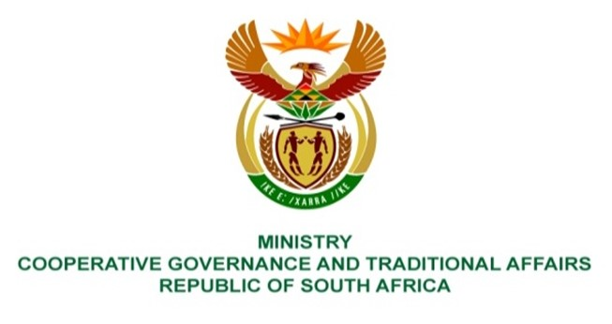

NATIONAL ASSEMBLY
QUESTIONS FOR WRITTEN REPLY

QUESTION NUMBER: 2159
DATE OF PUBLICATION: 03 SEPTEMBER 2021

QUESTION:

2159. Mr K Ceza (EFF) to ask the Minister of Cooperative Governance and Traditional Affairs:

What remedial action has her department taken to respond to the tariff-hikes affecting historically poor and black communities during COVID-19, such as the community of Steve Tshwete Local Municipality? NW2449E
REPLY:

The Department of Cooperative Governance (DCoG) does support municipalities in relation to the provision of electricity to indigent household in line with the Free Basic Electricity (FBE) policy. However, the Department provides support and guidance to all municipalities (not particular) with regards to the provision of FBE to indigent households. It further assists with the identification of indigent households not collecting their FBE thus not benefiting from the provision of FBE and enable the necessary interventions to be effected.
Tariffs are levied for the use of municipal trading services. Section 75 A of Municipal Systems Act (MSA) under general powers to levy and recover fees, charges and tariffs, it also states that the municipality may Levy and recover fees, charges, or tariffs in respect of any function or service of the municipality
Electricity tariffs is governed and approved by the National Energy Regulator of SA (NERSA) in as per the Electricity Regulation Act (ERA) and water and sanitation tariffs are regulated by the Department of Water and Sanitation (DWS) through the norms and standards.The tariffs approvals are outside the mandate of the Department, however, the Department plays a two important roles through provision of Free Basic Electricity (FBE) for poor households who qualifies as Indegents and also through providing inputs during tariff increase consultations..

The above is done through the regular monitoring of monthly FBE executive summary reports which shows transactions for that particular month, quarterly reports reflecting a list of municipalities that are in arrears on their FBE accounts and quarterly reports reflecting details of access/collection of FBE tokens per municipality.

The Department works closely with Eskom (where Eskom is the licensed service provider), Provincial COGTAs and Municipalities; with the objective being to ensure that municipalities provides FBE to all qualifying indigent households receive FBE guided by the FBE Funding Agreement.

