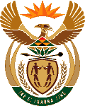
MINISTRY OF ENERGY
REPUBLIC OF SOUTH AFRICA

PRIVATE BAG x 96, PRETORIA, 0001, Tel (012) 406 7658
PRIVATE BAG x 9111, CAPE TOWN, 8000 (021) 469 6412, Fax (021) 465 5980

National Assembly Question: 2159 Ms N Nolutshungu (EFF) to ask the Minister of Energy.
Whether any relatives of Ministers (a) have shares in and/or (b) own companies that are Independent Power Producers? NW2316E

Reply:

I am not privy to the required information.

Approved / Not Approved

Mr J T Radebe, MP
Minister of Energy
Date:

