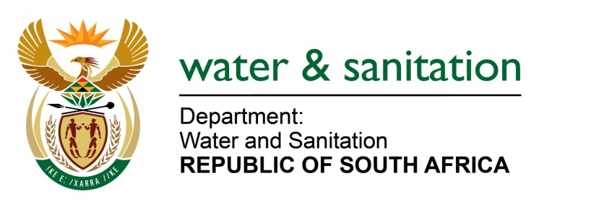

NATIONAL ASSEMBLY

FOR WRITTEN REPLY

QUESTION NO 2158

DATE OF PUBLICATION IN INTERNAL QUESTION PAPER: 03 September 2021
(INTERNAL QUESTION PAPER NO. 21)

2158. Mrs M R Mohlala (EFF) to ask the Minister of Water and Sanitation:

In light of the fact that water boards such as the Amatola Water Board have in the past five years been riddled with issues of corruption and political interference surrounding the appointment of board members, what strategies of intervention have been devised to strengthen governance at water boards?

NW2448E
---00O00---
MINISTER OF WATER AND SANITATION

Honorable Member, the Department of Water and Sanitation (the Department) is implementing the following interventions to strengthen governance at Water Boards:

- The Minister had 5 Provincial engagements in the Free State, Eastern Cape, Limpopo, Gauteng and KwaZulu- Natal. These provincial engagements were attended by the DWS Provincial Office, Provincial Government, Water Boards, Water Service Authorities and broader water and sanitation Committees and Forums.

- The engagements with Water Boards were mainly around issues of governance, financial viability and accountability and broader service delivery issues as per their mandate.

- The Minister, during the engagement in the Eastern Cape between 31 August to 2 September 2021, interacted with Amatola Water Board. The Minister noted with concern the issues of lack of stability both in the Board and Executive Management. The situation is exacerbated by a number of allegations including allegations of political interference.

- To stabilize Amatola Water Board the following decisions were made:
- The Department obtained a legal opinion on the Board Appointment process of Amatola Water.
- Probity Check was conducted on all new Board Members
- The Minister is currently implementing the outcomes of the legal opinion and probity Check.
- The Minister has processed a Cabinet Memorandum to appoint the permanent Chief Executive Officer of Amatola Water

---00O00---

