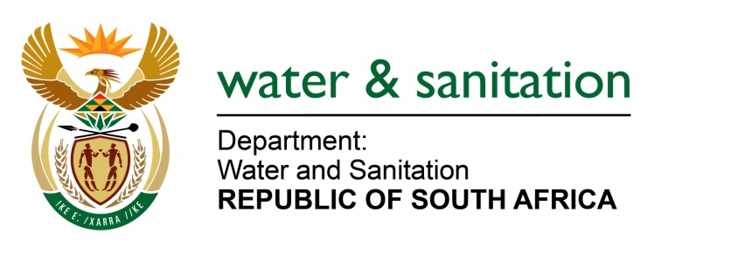

NATIONAL ASSEMBLY

FOR WRITTEN REPLY

QUESTION NO 2157

DATE OF PUBLICATION IN INTERNAL QUESTION PAPER: 14 OCTOBER 2016
(INTERNAL QUESTION PAPER NO. 30)

2157. Mr L J Basson (DA) to ask the Minister of Water and Sanitation:

With reference to the eight contracts related to the progress of Phase II of the Lesotho Highlands Water Scheme that are in the process of procurement, what is, in each case, the (a) nature of the work that tenders are sought for, (b) status of the procurement processes, (c) expected date of awarding the contract and (d) projected total value of the contract? NW2477E
---00O00---

REPLY:

Refer to Annexure A regarding the progress of the eight contracts of Phase II of the Lesotho Highlands Water Scheme.

ANNEXURE A
Contract # | Description | Status | Date of award | Budget Estimate | Award price
Water Transfer Contracts being negotiated/ recently awarded

3004 | D&S Western Access Road as Main Access Road to Polihali | Letter of Award issued | 10-Oct-16 | 75 000 000 | 66 702 034
3008 | D&S Telecommunications & Power Supply | Contract awarded | 23-Sep-16 | 40 000 000 | 37 390 414
3022 | D&S of Polihali Dam Diversion Tunnel | Letter of Award issued | 05-Sep-16 | 85 000 000 | 82 460 556
6004 | ESIA Western Access Corridor | Letter of Award issued | 08-Sep-16 | 5 000 000 | 4 979 752
6014 | ESIA Project Housing and Polihali Dam and Reservoir Site Establishment | Contract awarded | 01-Sep-16 | 10 000 000 | 8 973 543
6006 | RAP - Western Access Road & transmission line | Under negotiations | Expect early Nov 16 | 30 000 000 | Under negotiations
6010 | SHEQ Framework | Letter of Award issued | 09-Sep-16 | 1 000 000 | 660 100
6015 | RAP - Project Housing, main reservoir, major bridges & road realignments | Letter of Award issued | 23-Aug-16 | 90 000 000 | 85 477 163
 |  |  | Total | 336 000 000 | 286 643 562
D&S = Design and Construction supervision
ESIA = Environmental Social Impact Assessment
RAP = Resettlement Action Plan
SHEQ = Safety Health Environment and Quality

