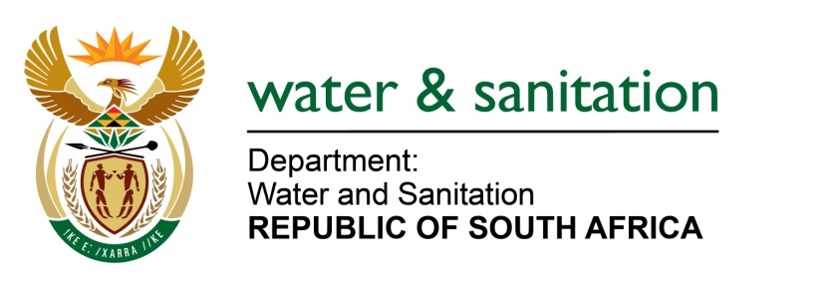

NATIONAL ASSEMBLY

FOR WRITTEN REPLY

QUESTION NO 2156

DATE OF PUBLICATION IN INTERNAL QUESTION PAPER: 03 SEPTEMBER 2021
(INTERNAL QUESTION PAPER NO. 21)

2156. Mrs M R Mohlala (EFF) to ask the Minister of Water and Sanitation:
(1) Whether he has disbanded the advisory committee that was set up by the former Minister of Human Settlements, Water and Sanitation; if not, what is the position in this regard; if so,
(2) whether the progress reports which had been compiled by the advisory committee were collected, given that these were compiled from taxpayers’ money; if not, why not; if so, what are the relevant details?
NW2446E

---00O00---
MINISTER OF WATER AND SANITATION
- The contracts of the advisory committees that were set up by the former Minister of Human Settlements, Water and Sanitation, were linked to her term of office in the Department of Water and Sanitation. Due to the fact that the tenure of the former Minister ended on 5 August 2021, the advisory committees was given 30 days’ notice from this date and terminated on 4 September 2021.

- The Chairpersons of the respective committees were requested to prepare and submit close-out reports. The Water Services Advisory Committee has submitted its close-out report. The other Committees will table their reports when they meet with the Minister.

---00O00-

