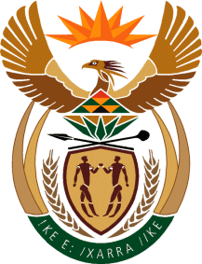

MINISTRY OF TOURISM
REPUBLIC OF SOUTH AFRICA

Private Bag X424, Pretoria, 0001, South Africa. Tel. (+27 12) 444 6780, Fax (+27 12) 444 7027
Private Bag X9154, Cape Town, 8000, South Africa. Tel. (+27 21) 469 5800, Fax: (+27 21) 465 3216

NATIONAL ASSEMBLY:

QUESTION FOR WRITTEN REPLY:
Question Number: 2153
Date of Publication: 2 June 2023
NCOP IQP Number: 21
Date of reply: 16 June 2023

Mr K P Sithole (IFP) to ask the Minister of Tourism:
Whether, following the Tourism Budget Vote in 2019, during which a number of recommendations were made to the former minister, such as ensuring that the 2019-2024 Strategic Plans for her department and SA Tourism are anchored on increasing participation of citizens in villages, townships and small towns, as well as explicit programmes and/or projects which prioritise such areas of society, she has found that these recommendations have been achieved; if not, why not; if so, what are the full, relevant details in this regard? NW2444E

REPLY:

I have been informed by the Department that it has projects in rural areas, villages, townships and small towns across all the line function branches of the Department. Projects include amongst others:

- Infrastructure products /development;
- Skills development;
- Enterprise development;
- Experience enhancement; and
- Market access.

SA Tourism also has a focus on grading of establishments as well as support for bidding and hosting of business events in rural areas, villages, townships and small towns in our country.

