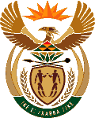
MINISTER OF ENERGY
REPUBLIC OF SOUTH AFRICA

PRIVATE BAG x 96, PRETORIA, 0001, Tel (012) 406 7658
PRIVATE BAG x 9111, CAPE TOWN, 8000 (021) 469 6412, Fax (021) 465 5980
National Assembly Question: 2153
2153. Ms N V Mente (EFF) to ask the Minister of Energy:

What has been the year-on-year percentage change for electricity demand in the country in the past three financial years? NW2308E

Reply:

The spreadsheet is hereto attached:

Approved / Not Approved

Mr J T Radebe, MP
Minister of Energy
Date

