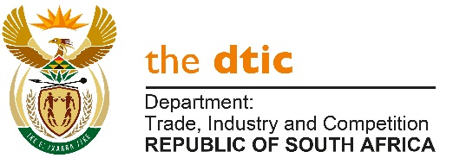

THE NATIONAL ASSEMBLY

QUESTION FOR WRITTEN REPLY

QUESTION NO. 2152

Mr M J Cuthbert (DA) to ask the Minister of Trade, Industry and Competition:
Whether his department ever investigated allegations of the awarding of incentives through the Industrial Financing Branch to family members of certain persons (names furnished); if not, what is the position in this regard; if so, (a) what was the outcome in each case and (b) will he furnish Mr M J Cuthbert with the further relevant details? [NW2717E]

REPLY

I am advised by the Director-General that the Department has not received any allegations of the awarding of incentives through the Industrial Financing Branch to family members of the officials mentioned.Therefore, no investigations have been necessary.

-END-

