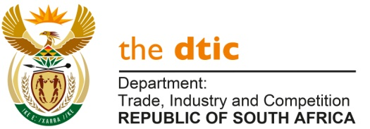

NATIONAL ASSEMBLY

QUESTION FOR WRITTEN REPLY

QUESTION NO. 2150

Mr M.J Cuthbert (DA) to ask the Minister of Trade and Industry:

(1) Whether, with reference to his reply to question 1107 on 22 June 2020, a certain person (name furnished) (a) took and (b) was approved for sabbatical leave on more than one occasion prior to 9 February 2018 to 8 February 2019; if so, what are the relevant details;

(2) whether the sabbatical leave of the specified person was approved in line with the regulations of the Department of Public Service and Administration; if not, what is the position in this regard; if so, (a) for how long was the leave taken and (b) on what date was each leave segment taken? [NW2715E]

REPLY
I am advised by the Department that:
- The sabbatical leave was not taken. The employee in question was granted an International Scholarship and sabbatical leave was approved for this purpose for the period 1 October 2017 until 30 September 2018. Due to personal circumstances, the employee could not take up the scholarship and returned to work on 27 November 2017 and the sabbatical leave for the period 1 October 2017 until 24 November 2017 was subsequently converted to unpaid leave and is being recovered.

- The sabbatical leave for the period 9 February 2018 to 8 February 2019 was approved in line with the Departmental policy on sabbatical leave as the Department of Public Service and Administration does not specifically provide for sabbatical leave, but allows departments to determine their own sabbatical leave policies.

- The original approval was granted for a period of 12 months, from 9 February 2018 until 8 February 2019. The Accouting Officer did, however, approve a deviation from the 12 months consecutive sabbatical leave to allow for taking the leave in non-consecutive intervals as and when required, provided that the total period of leave taken does not exceed 12 months (261 working days). However, the employee took 249 working days out of the 261 working days; and

- A breakdown of each period taken is provided in the table below:
2018
Period | No. of working days
09.02.2018 – 22.02.2018 | 10
27.02.2018 – 07.03.2018 | 7
29.03.2018 – 10.05.2018 | 27
01.06.2018 – 22.06.2018 | 16
02.07.2018 – 06.07.2018 | 5
13.08.2018 – 31.08.2018 | 15
10.09.2018 – 18.09.2018 | 7
12.11.2018 – 26.11.2018 | 11
 | 98 working days
2019
21.01.2019 – 08.02.2019 | 15
18.02.2019 – 29.03.2019 | 29
08.04.2019 – 16.04.2019 | 7
06.05.2019 – 14.05.2019 | 6
10.06.2019 – 21.06.2019 | 9
26.06.2019 – 28.06.2019 | 3
08.07.2019 - 30.07.2019 | 17
31.07.2019 – 04.09.2019 | 25
06.09.2019 – 20.09.2019 | 11
23.09.2019 | 1
25.09.2019 | 1
03.10.2019 – 08.11.2019 | 27
 | 151 working days
Total working days taken | 249 working days

-END-

