DEPARTMENT: PUBLIC ENTERPRISES
REPUBLIC OF SOUTH AFRICA
NATIONAL ASSEMBLY

QUESTION FOR WRITTEN REPLY

QUESTION NO.: PQ 215

QUESTION:

215. Mr B N Herron (Good) to ask the Minister of Public Enterprises:
(1) With reference to the commitment by the President of the Republic, Mr M C Ramaphosa, in 2022, that the Government would procure and add an additional 6800 MW of energy capacity to the grid and 5200 MW was to be procured in Bid Window 6, which has not been met allegedly due to Eskom’s transmission capacity, what are the reasons that (a) Eskom is unable to provide the transmission capacity when it was aware of the President’s commitments and (b) the Generation Connection Capacity Assessment is incorrect;
(2)(a) which locations in the Republic does Eskom’s transmission grid have capacity to connect additional renewable energy from the Independent Power Producers (IPPs) and (b) what justification can be given for the prioritisation of a long term Karpowership deal over adding new capacity through wind; (3)(a) how does the grid have the transmission capacity in the Western Cape for power supplied by ships and/or barges but not by wind and (b) what reforms are going to be put in place to restructure the bid procurement process so that IPPs are able to assist in the energy crisis as soon as possible?

REPLY

According to the information received from Eskom

1(a)
Reasons why Eskom is unable to provide the transmission capacity when it was aware of the President’s commitments:
Since the launch of the IPP programmes (Bid Windows 1 to 4), close to 6.1 GW of new generation capacity has been integrated into the power system. Following the announcement of the preferred bidders for Bid Window (BW) 5/6, there have been IPPs that participated in the private procurement process and quickly secured grid capacity, mainly in the Western, Eastern, and Northern Cape. The Transmission network capacity in these areas has been taken up according to grid code requirements, which requires Eskom to provide non-discriminatory open access to the grid. This has resulted in network constraints, requiring substantial augmentations before new generation capacity can be connected to the system.

To address this, the 10-year Transmission Development Plan (TDP 2022) identified the new infrastructure required to implement the IRP 2019 and Eskom’s 2035 Corporate Strategy. However, it takes time to establish new transmission infrastructure (especially the building of long lines and substations) mainly because of servitude acquisitions and constructability challenges. Eskom is aware of these challenges and is making every effort to expedite the building programme by engaging key stakeholders in the government, as well as in the private sector. A number of servitudes have already been acquired. Funds will also have to be mobilised for the capital expenditure. Different mechanisms are currently being explored.

1(b)
Reasons for the Generation Connection Capacity Assessment (GCCA) being incorrect:
At the time of publishing the GCCA 2024 in March 2022, based on information on the successful bidders from BW 1 to 5 of the DMRE IPP Procurement Programmes, the GCCA provided a correct indication of the potential capacity available on the transmission network to facilitate the connection of new generation projects. In summary, the potentially available capacities for the connection of new generation projects, taking into consideration the interest expressed by IPPs, as well as the environmental impact, is as follows:
- Southern regions of the country accounted for ~ 4.5 GW (Western and Eastern Cape, Hydra Cluster, excluding the Northern Cape that had already run out of capacity)
- Northern regions of the country accounted for ~ 12.1 GW (Free State, North West, Limpopo, Mpumalanga, and Gauteng)

While the regulated procurement process, which was managed by the DMRE/IPP office and their timelines for BW 6, was progressing with procuring 4.2 GW of generation capacity, mainly from wind and solar. The privately procured IPPs secured most of the available capacity in the southern regions by following the due processes associated with grid connection applications. This resulted in a significant reduction in the generation capacity procured via BW 6 to around 1 GW.

The GCCA report was accurate at the time of release based on the snapshot view of committed generation projects and network assumptions. The national capacity published is based on the assumption of known generation commitments at the time of publication. Between publications, various applications for connections were made by IPPs that participate in the DMRE-/IPPO-regulated procurement programmes and the private sector IPPs.

2(a)
Which locations in the Republic does Eskom’s transmission grid have capacity to connect additional renewable energy from the IPPs:
Based on the GCCA 2024, approximately 12 GW of transmission network capacity is available in the northern regions of the country, for example, Free State, North-West, Mpumalanga, Limpopo, and Gauteng, as indicated in Figure 1 below.

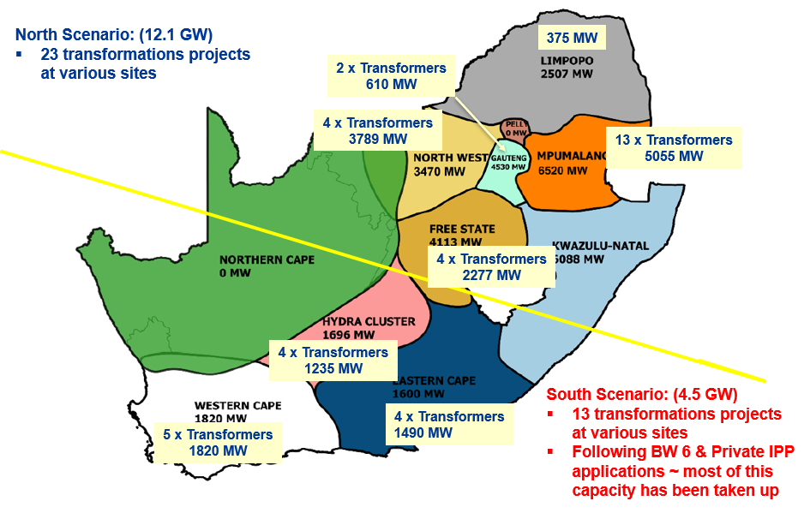
Figure 1: Available grid capacity for renewable energy (RE)

2(b)
What justification can be given for the prioritisation of a long-term Karpowership deal over adding new capacity through wind:
The DMRE determines the supply options for the country and what takes priority. Eskom or DPE has NO role in this process, kindly direct all questions on “Karpowership deal” to DMRE.

Eskom must be an off taker of power and sign the required Power Purchase Agreements with parties determined by DMRE/IPPO. The role of Eskom Transmission is to provide open and transparent access to the interconnected power system for both load and generation customers. All applicants that require a connection to the transmission system follow a grid connection application process, as required by the South African Grid Code. In the case of Karpowership, the DMRE/IPPO procurement process for RMIPPP was followed, and on the announcement of their successful bid, transmission network capacity was allocated on the basis that all conditions for connection were met. In the event that the DMRE/IPPO or, for that matter, the IPP decides not to go ahead with the project for whatever reason, then the transmission capacity that was allocated for the project would be released back into the pool for other potential IPPs to consider.

3(a)
How does the grid have the transmission capacity in the Western Cape for power supplied by ships and/or barges but not by wind:
Following on from (2b), Transmission capacity is reserved on the announcement of preferred bidders by the DMRE/IPPO. Because of the lack of transmission network capacity in the broader Cape region, as explained above, no new generation capacity can be connected until new transmission infrastructure, as identified in the TDP, is implemented.

3(b)
What reforms are going to be put in place to restructure the bid procurement process so that IPPs are able to assist in the energy crisis as soon as possible:
The IPP procurement process is managed by the DMRE / IPPO. Eskom’s Grid Access Unit (GAU) is reviewing its processes and is coordinating on behalf of the electricity supply industry the introduction of Grid Capacity Allocation Rules to “level the playing field” in allocating grid capacity. It is expected that these rules shall require the sanctioning by NERSA’s structures, such as the Grid Code Advisory Committee, for implementation. These rules will facilitate the connection of projects on a ‘first ready – first connected’ principle which will result in a faster connection of new capacity to the grid.

We will ensure that further details on the implementation of the Transmission Development Plan and relevant timeframes are publicized as soon as possible.

Remarks: Reply: Approved / Not Approved

Jacky Molisane P J Gordhan, MP
Acting Director-General Minister
Date: Date:

