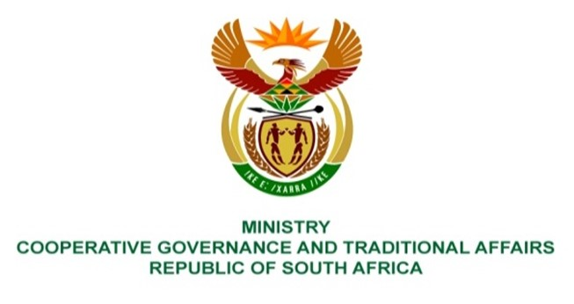

NATIONAL ASSEMBLY
QUESTION FOR WRITTEN

QUESTION NUMBER 215
DATE OF PUBLICATION: 10 FEBRUARY 2022

QUESTION:

215. Mrs S M Mokgotho (EFF) to ask the Minister of Cooperative Governance and Traditional Affairs:
- What steps has she taken to ensure that the Moses Kotane Local Municipality completes the Reconstruction and Development Programme (RDP) houses it built in 2019 in Ledig in Wards 14 and 28 and
- on what date is it envisaged the the RDP houses will be (i) completed and (ii) occupied by their rightful owners? NW219E

REPLY:
- Moses Kotane Local Municipality is a beneficiary and an end user of the Reconstruction and Development Programme(RDP). The Department of Human Settlements is responsible for the implementation of the programme through its provincial department, which relies on the local municipality to facilitate the beneficiaries. The question can be best answered by the relevant department.

