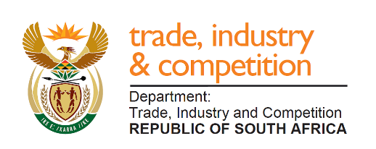
NATIONAL ASSEMBLY

QUESTION FOR WRITTEN REPLY

QUESTION 215

Mrs Y N Yako (EFF) to ask the Minister of Trade and Industry:
What (a) number of (i) companies have benefited from the black industrialist programme since its establishment and (ii) jobs have been created by each company and (b) are the relevant details of the (i) name of each company, (ii) directors and (iii) number of directors in each specified case? NW291E

REPLY
I am advised that a total of 149 companies have been approved under the Black Industrialist Scheme (BIS) since inception to 31 January 2020, supporting 22 176 jobs. This excludes the IDC’s programme.
The list of all approved enterprises and projects across all incentives has been published in the 2018/19 which can be accessed from the Department’s website: http://www.thedtic.gov.za/wp-content/uploads/2018-2019_Annual_Incentive_Report.pdf

-END-

