36/1/4/1(201900030)
NATIONAL ASSEMBLY

FOR WRITTEN REPLY

QUESTION 215

DATE OF PUBLICATION IN INTERNAL QUESTION PAPER: 15 FEBRUARY 2019 (INTERNAL QUESTION PAPER NO 2-2019)

215. Mr D America (DA) to ask the Minister of Police:

- What number of (a) murders were reported at the Tembisa Police Station in the (i) 2015-16, (ii) 2016-17 and (iii) 2017-18 financial years and (b) the specified murders resulted in a successful conviction;

- what number of (a) women and (b) chlld£Rn were murder victims?

REPLY:

NW225E

(1)(a) The number of murders, whlch were reported at the Tembisa Police Station, is as follows:
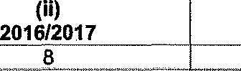
(i) 2015/2016
20
(iii)
2017/2018
16

(1)(b) The number of murders, which resuked in successful convictions, is as follows:

(i)  2015/2016 |  |  | 2016/2017 |  | (iii)  2017/2018
CAS  Number |  | Conviction | CAS  Number | Conviction | CAS  Number | Conviction
706/04J204 5 |  | 14 years  imprisonment | 544/03/2016 | 15 years  imprisonment | 434/03/2017 | 5 years  imprisonment
78/05/2015 |  | 5 years  imprisonment | 572/03/2016 | 5 years  imprisonment | 24/04/2017 | 5 years  i risonment
691/08/2015 |  | Life  imprisonment | 13/05/2016 | 5 years  imprisonment | 393/06/2017 | 10 years  imprisonment
316/11/2015 |  | 5 years  imprisonment | 717/07/2016 | Life  imprisonment | 48/12/2017 | 5 years  imprisonment
841/01/2016 |  | 5 years  imprisonment | 747/07/2016 | 6 years imprisonment
 |  |  | 128/08/2016 | ”80 years  imprisonment
 |  |  | 737/08/2016 | 5 years  imprisonment
 |  |  | 35/09/2016 | 5 years  imprisonment
 |  |  | 101/11/2016 | 7 years  Imprisonment

2

(2)(a)(b) The number of women and children, who were murder victims, is as follows:
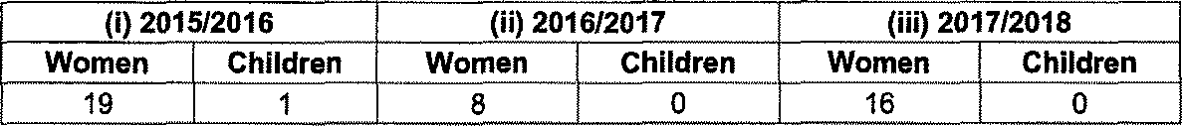
(i) 2015/2016
(ii) 2016/2017
(iii) 2017/2018
Women Children Women Children Women Children 19 1 8 “ 0 ”“ 16 " 0

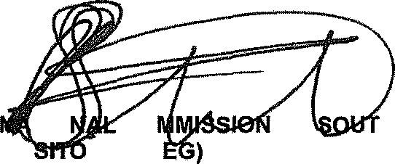
Reply to question 215 recommended

TO CO KJ LE (SO

Date: 70l8 -02- $
GENERAL ER: H AFRICAN POLICE SERVICE

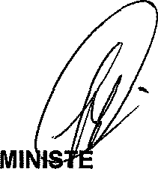
Reply to question 215 approved/

R OF POLICE BH CELE MP

Date: •

