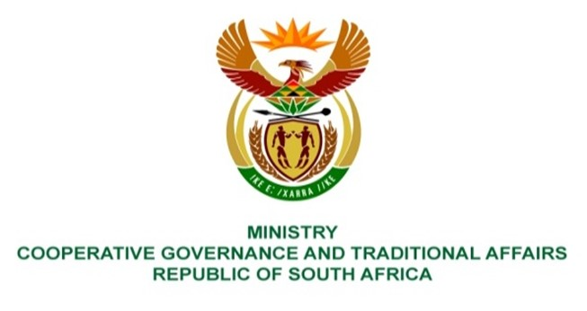

NATIONAL ASSEMBLY
QUESTION FOR WRITTEN REPLY
QUESTION NUMBER 2149
DATE OF PUBLICATION: 3 JUNE 2022

QUESTION:

Mr B N Herron (Good) to ask the Minister of Cooperative Governance and Traditional Affairs: [◙2149.]

- During the period of the 6th Parliament, what total number of questions (a) for (i) written and (ii) oral reply have members posed to her department about specific municipalities across the Republic, (b) required the municipalities to provide information in order for her to reply to the questions and (c) were answered with replies that relied on information obtained from municipalities, either directly and/or through a provincial government Member of the Executive Council;
- what (a)(i) is the total number and (ii) are the names of municipalities that refused to provide information requested by her in order to provide the replies to the members’ questions and (b) reasons did the specified municipalities offer for refusing to provide the information needed for her to reply to questions from members;
- whether any municipalities have refused to answer parliamentary questions and maintained that parliamentary questions are intended to hold the executive accountable for their official decisions and actions and cannot be used to hold local government accountable for its decisions and actions and/or maintained that there is no statutory provision that requires the municipality to provide information relating to or answers to parliamentary questions; if not, what is the position in this regard; if so, (a) what are the relevant details and (b) how has she regarded and/or dealt with such positions? NW2552E

REPLY:
- (a) During the period of the 6th Parliament until 2 September 2022, the Minister received about 489 Parliamentary questions from the National Assembly of which (i) around 439 were for written reply and (ii) roughly 50 were for oral reply; (b) approximately 163 written reply, and about 6 oral reply and (c) around 169 of the parliamentary questions posed to the Department relate to service delivery matters in municipalities. The responses are solicited from the respective municipalities and provincial government departments.

- There were no municipalities that refused to provide answers to parliamentary questions received, however some responses were not within the 10 working days timeframe as per Parliamentary prescripts.

- Not applicable.

