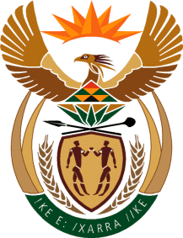

MINISTRY OF TOURISM
REPUBLIC OF SOUTH AFRICA

Private Bag X424, Pretoria, 0001, South Africa. Tel. (+27 12) 444 6780, Fax (+27 12) 444 7027
Private Bag X9154, Cape Town, 8000, South Africa. Tel. (+27 21) 469 5800, Fax: (+27 21) 465 3216

NATIONAL ASSEMBLY:

QUESTION FOR WRITTEN REPLY:
Question Number: 2147
Date of Publication: 4 September2020
NA IQP Number: 35
Date of reply: 21 September 2020

Mr M S F de Freitas (DA) to ask the Minister of Tourism:
What (a) steps has her department taken to ensure accessibility of tourism sites in the past three financial years to date, (b) are the details of the success achieved in this regard, (c) are the details of how accessibility of tourism sites is measured, (d) are the details of the road infrastructure that was (i) developed, (ii) upgraded and (iii) maintained in the past three financial years to date and (e) are the additional tourism offers that have been added in this regard in each instance?
NW2712E

REPLY:

Various role players contribute to tourism. Tourism will always benefit from any maintenances, upgrades or new developments to any infrastructure.

Road infrastructure is not the competency of the Department of Tourism nor does the department keep the requested information pertaining to the road infrastructure of the country.The Honourable member may refer the question to the Minister of Transport.

(a) to (e) Not applicable.

