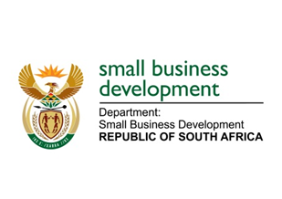
NATIONAL ASSEMBLY
QUESTION FOR WRITTEN REPLY

“2142. Inkosi B N Luthuli (IFP) to ask the Minister of Small Business Development:
Whether, considering that the former Minister shared in her Budget Vote of 2017 that in the 2016-17 financial year the Small Enterprise Finance Agency (SEFA) disbursed just over R1 billion to small-, medium- and micro enterprises and co-operatives, which benefited approximately 44 000 enterprises, although for the third quarter of the 2022-23 financial year SEFA approved R249 million in loans and disbursed only R550 million in loans, thereby achieving only 41% of its performance targets, she has assessed this as a regression in her department; if not, what is the position in this regard; if so, what are the relevant details?” NW2433E

REPLY:
I have been advised that:

The table below outlines the Small Enterprise Finance Agency (sefa) loan book performance in the referenced years:
Financial Year | Approvals | Disbursements | # of SMMEs Financed | # of Jobs Facilitated
FY2016/17 (Audited numbers) | R827 million | R1, 076 billion | 43 211 | 55 997
FY2022/23 (un-audited numbers) | R1, 706 billion | R2, 427 billion | 74 762 | 104 547

So, it is clear that Sefa has not regressed – infact it has more than doubled its disbursements from 2016/17 to 2022/23 . To break down this further and for the financial year ending 31 March 2023, the Minister indicated in her budget speech that sefa through its development finance interventions and programmes, cumulatively financed 74 762 SMMEs and Co-operatives and disbursed R2.4 billion to these enterprises.

Through these disbursements, sefa was able to reach:
• 74 486 black owned SMMEs to the value of R2.1 billion.
• 15 535 youth owned SMMEs to the value of R564 million.
• 72 651 women owned SMMEs to the value of R928 million.
• 2 953 township based SMMEs to the value of R541 million.
• 66 302 rural-based SMMEs to the value of R952 million.

Collectively, these funding interventions have created 32 665 new jobs and sustained 71 882 existing jobs.

This performance is by no means reflecting a regress in the performance of sefa at the end of the financial year ending in 31 March 2023.

