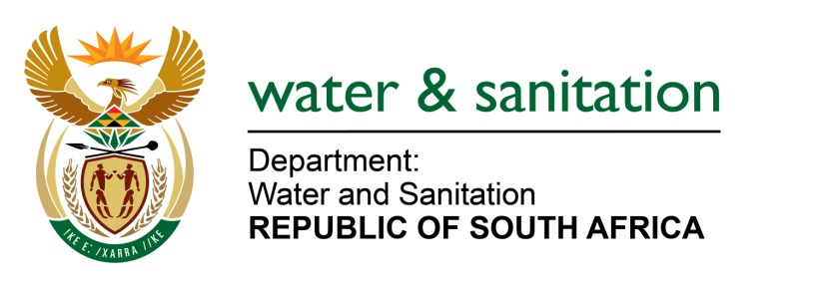

NATIONAL ASSEMBLY

FOR WRITTEN REPLY

QUESTION NO 2141

DATE OF PUBLICATION IN INTERNAL QUESTION PAPER: 02 JUNE 2023
(INTERNAL QUESTION PAPER NO. 21)

2141. Ms S A Buthelezi (IFP) to ask the Minister of Water and Sanitation:
Considering that there have been suspicions that water tanker business owners are sabotaging water supplies so they can keep on raking in millions of Rand even in the face of the current cholera outbreak, what steps has his department taken to address and/or get to the bottom of such serious allegations? NW2432E
---00O00---

MINISTER OF WATER AND SANITATION
Water tanks are an interim measure employed by municipalities in areas where there is insufficient infrastructure and shortages of water supply through the water distribution system. This interim measure ensures availability of water to those affected communities as an alternative.

It is a costly exercise and should be properly managed by municipalities to ensure that these services are procured through a competitive bidding process. The key solution is proper operations and maintenance of the available infrastructure, to avoid water supply interruptions. The department is also supporting municipalities through its grants to fund refurbishment and upgrades, including the development of new infrastructure to meet the water demands efficiently, with proper water services to all.

All water sources or water services provided through tankers must be tested for acceptable water quality before being dispatched to the communities concerned. This water testing exercise should be conducted daily and consistently to ensure compliance with SANS on water quality. The norms and standards of the department prescribe that if traces of poor water quality are identified, the municipalities must immediately inform the communities.
---00O00---

