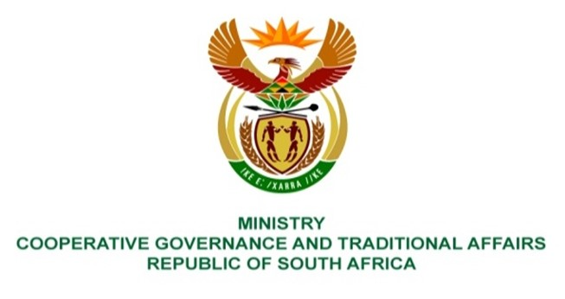

NATIONAL ASSEMBLY
QUESTIONS FOR WRITTEN REPLY

QUESTION NUMBER 214
DATE OF PUBLICATION: 10 FEBRUARY 2022

214. Mrs S M Mokgotho (EFF) to ask the Minister of Cooperative Governance and Traditional Affairs:

In light of the fact that the Moses Kotane Local Municipality in North-West built two reservoirs in 2019 in order to supply the community of Ledig with water but to date the reservoirs are without water, (a) what are the reasons that the reservoirs are not in use and (b) on what date is it envisaged they will be put to use? NW218E
REPLY:
The information received from the North-West Province:
- There are no two (2) reservoirs that were built in 2019 and the only existing reservoir is the 3,5 ML/day reservoir that was built in 2009 and on its own does not have sufficient capacity to cater for the demand, it feeds from Valkop Water treatment works.

- As per the above, it is the 2009 built 3,5 ML/Day that requires refurbishment or upgrade to cater for its demand.

