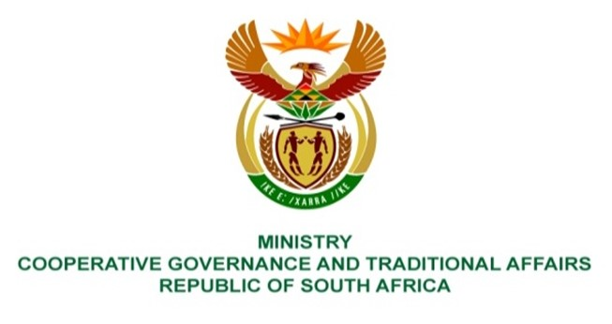

NATIONAL ASSEMBLY
QUESTION FOR WRITTEN
QUESTION NUMBER 2139
DATE OF PUBLICATION: 27 MAY 2022

QUESTION:

2139. Inkosi B N Luthuli (IFP) to ask the Minister of Cooperative Governance and Traditional Affairs:
In light of the recent floods in KwaZulu-Natal that have exposed the weaknesses in disaster management response in the specified province, what measures have been put in place to evaluate the effectiveness of the disaster management centres in the province to ensure that the centres are properly equipped to deal with future disasters of this kind? NW2548E

REPLY:
The National Disaster Management Centre each year monitors legislative compliance to the Disaster Management Act, 2002 (Act No. 57 of 2002) in all Provincial Disaster Management Centres (PDMC) and two Municipal Disaster Management Centres (MDMC) located in each province. These assessments are done with the PDMC and then feedback is provided immediately on key issues that have been identified. Provinces and each municipality to ensure that they comply with the requirements of the Disaster Management Act, 2002 (Act No. 57 of 2002), including to develop and implement a comprehensive disaster management plan. The District Development Model (DDM), presents an opportunity that, in the context of “Joint One Plans” and “One Budgets”, organs of state and institutional role-players will be able to coordinate and align the implementation of their disaster (risk) management plans within each District and Metropolitan space across the country.

