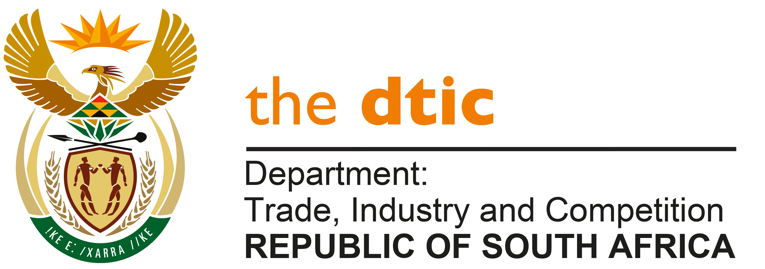

THE NATIONAL ASSEMBLY

QUESTION FOR WRITTEN REPLY

QUESTION NO. 2139

Mr A N Sarupen (DA) to ask the Minister of Trade, Industry and Competition [Interdepartmentally transferred from Finance]:
Whether, with reference to the management of systemic risk to the South African financial system in the economy, his department has conducted an assessment of the impact of defaults on the loans to fund black economic empowerment deals; if not, why not; if so, what are the relevant details? [NW2428E]

REPLY
The department has advised me of the following information regarding the assessment of defaults on loans by the following dtic entities, The Broad-Based Black Economic Empowerment (B-BBEE) Commission; Industrial Development Corporation (IDC); National Empowerment Fund (NEF); and the Automotive Industry Transformation Fund (AITF).

Over the period from 1 April 2015 to 31 March 2021, the IDC approved R45.6 billion for companies with more than 25% black shareholding. R40.2 billion was disbursed (including guarantees that were issued). The amount of R978 million (2.4%) was written off.

To date, the NEF has approved approximately R11.3 billion. Over R7.504 billion has been disbursed to majority black owned and managed businesses across all sectors of the economy. To date, over R3.9 billion has been repaid by investees. The cumulative impairment balance of R746 million has been provided for against the gross portfolio balance of R3,8 billion.

From January 2021 to September 2021, the AITF has approved R 82 136 304 to businesses that have a 51% or more shareholding.
R 6 619 462 has been disbursed to date. There are no current defaults or written off amounts to date.
The AITF begun processing funding applications in January 2021.

The B-BBEE Commission will be conducting an assessment through its panel of researchers. At this point the Commission has noted the decline of registered empowerment deals from 109 (2019) to 52 (2020) registered last year.

-END-

