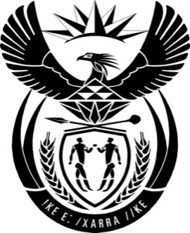

THE PRESIDENCY: REPUBLIC OF SOUTH AFRICA
Private Bag X1000, Pretoria, 0001
NATIONAL ASSEMBLY
QUESTIONS FOR WRITTEN REPLY

QUESTION NO: 2138.

Date Published: October 2016

Mr D J Maynier (DA) to ask the President of the Republic:
(1) Whether the statement issued by the Minister of Mineral Resources on 1 September 2016 was issued in the Minister’s personal capacity; if not, what are the relevant details; if so, why did the Minister state in a reply to written question 1892 on 22 September 2016 that he was not speaking in his personal capacity;
(2) whether the specified statement reflects Cabinet’s position on the recommendations contained in the inter-ministerial committee’s report; if not, why not; if so, why did the Minister claim in a reply to written question 1892 on 22 September 2016 that four of the specified recommendations were approved by Cabinet;
(3) whether any action has been taken against the specified minister for issuing the specified statement; if not, why not; if so, what are the relevant details? NW2455E

Reply:
I had indicated in my previous reply that the statement issued by the Minister of Mineral Resources, Mr Mosebenzi Zwane on 1 September 2016, on the work of the task team established to consider the implications of the decisions of certain banks and audit firms to close down the accounts and withdraw audit services from the company named Oakbay Investments, was issued in his personal capacity and not on behalf of the task team or Cabinet. I am not in the position to answer why the Minister Zwane in his reply on 22 September 2016 said that he was not speaking in his personal capacity. The question in this regard must be directed to the Minister.
I reprimanded the Minister for the statement.

