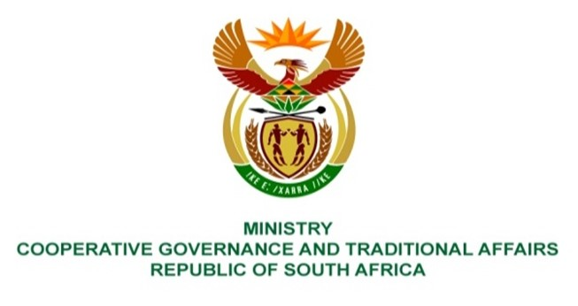

NATIONAL ASSEMBLY
QUESTION FOR WRITTEN REPLY

QUESTION NUMBER 2137
DATE OF PUBLICATION: 27 MAY 2022

QUESTION:

2137. Mr W Horn (DA) to ask the Minister of Cooperative Governance and Traditional Affairs:
Whether, with regard to the intervention by the national Government into the administration of the Mangaung Metropolitan Municipality in terms of section 139(7) of the Constitution of the Republic of South Africa, 1996, and the terms of reference issued by her in respect of the intervention, the intervention team is empowered to determine whether motions of no confidence in elected office bearers of the council of the specified municipality may be allowed to serve before the municipal council while the intervention is in place; if not, what is the position in this regard; if so, what legislative provisions does the intervention team rely on in this regard? NW2545E

REPLY:
The intervention team in Managung Metropolitan Municipality is not empowered to determine whether motions of no confidence in elected office bearers may be allowed or not, while the intervention is in place. Thus, the scope and responsibilities of the intervention team are mainly related to the implementation of the Financial Recovery Plan, and not extended to cover matters relating to political decisions, and thus, Municipal Council resolutions on whether or not to remove an elected office bearer is not part of the implementation of the Financial Recovery Plan. The procedural requirements pertaining to a political decision that a Municipal Council is entitled to take, are prescribed in sections 29, 30, 40 and 58 of the Municipal Structures Act, No. 117 of 1998.

