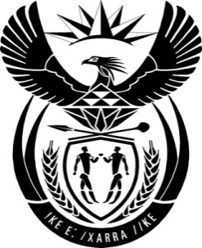

THE PRESIDENCY: REPUBLIC OF SOUTH AFRICA
Private Bag X1000, Pretoria, 0001
NATIONAL ASSEMBLY
QUESTIONS FOR WRITTEN REPLY

QUESTION NO: 2137

Date Published: October 2016

Mr D J Maynier (DA) to ask the President of the Republic:

Whether, with reference to his reply to oral question 17 on 13 September 2016, he has engaged with the Minister of Mineral Resources on the controversy surrounding the statement issued by the Minister on 1 September 2016; if not, why not; if so, what are the relevant details? NW2454E
Reply:
I reprimanded the Minister of Mineral Resources for the statement.

