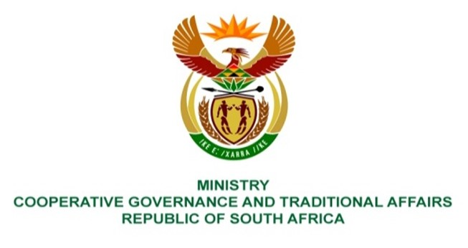

NATIONAL ASSEMBLY
QUESTIONS FOR WRITTEN REPLY

QUESTION NUMBER 213
DATE OF PUBLICATION: 10 FEBRUARY 2022

QUESTION:

213. Mrs S M Mokgotho (EFF) to ask the Minister of Cooperative Governance and Traditional Affairs:

What steps has she taken to ensure that the Moses Kotane Local Municipality, in North-West, provides water to the communities of Wards 14, 28 and 30 in Ledig, which have been without water for some time? NW217E

REPLY:

The Moses Kotane Local Municipality (MKLM) is the Water Services Authority (WSA) in its area of jurisdiction. According to MKLM, it is currently servicing Wards 14, 28 and 30 in Ledig by carting water, storing it in tanks and providing communities through standpipes installed in various strategic points. The water is supplied by Magalies Water Board. In some areas however water is supplied from boreholes that were donated by the Traditional Council as a short-term solution. The implementation of a bulk water project mentioned below aims to ensure a sustainable water supply to the communities of Ledig.

In accordance with section 154 of the Constitution, the Department of Corporative Governance (DCOG) supports and strengthens the MKLM to perform their WSA functions of ensuring access to water services to the communities MKLM. DCOG through the Municipal Infrastructure Support Agent (MISA) deployed professionally registered engineers to MKLM who assist throughout the water project life cycle and water provision function responsibilities. The deployed engineers further support MKLM by coordinating other service delivery role players like the Department of Water and Sanitation (DWS) in accordance with the District Development Model (DDM). The deployed MISA engineers support MKLM with the implementation of the following project aimed to ensure the provision of water to the communities of Ledig.

According to MKLM, a bulk water project to address the water challenges in Wards 14,28 and 30 was initiated few years ago. The implementation model was through a tripartite agreement of Bakubung Platinum Mine, Maseve Mine and MKLM. The original scope as approved by the DWS included the construction of a pump station, 5 mega-liter (ML) reservoir and a bulk pipeline. Phase 1 of the bulk water supply project was completed in 2020, which excluded the 5 ML reservoir and the bulk main pipeline. MKLM is currently in the process of procuring a contractor for the construction of the reservoir and the associated bulk main pipeline.

The successful implementation of this project will ensure that there is sustainable water supply in the three wards.

