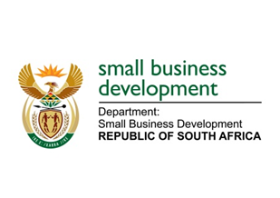
NATIONAL ASSEMBLY
QUESTION FOR ORAL REPLY
DUE TO PARLIAMENT: FRIDAY, 16 JUNE 2023

“2128. Inkosi B N Luthuli (IFP) to ask the Minister of Small Business Development:
With reference to her announcement during her department’s budget vote that 2.5 million small-, medium- and micro-enterprises (SMMEs) currently employ almost 8 million people in the Republic, what are the details of the material support that her department offers to lessen this burden on struggling SMMEs as they often struggle to access and benefit from the services of agencies such as the Small Enterprise Development Agency?” NW2413E

REPLY:
I have been advised:

That the Small Enterprise Development Agency (Seda) has a wide footprint in the country that consists of fifty-three (53) branches and fifty-six (56) co-location points with the intention to widen access to Seda services in underserviced and rural South Africa. The Small Enterprise Finance Agency (sefa) is working with Seda in increasing awareness across various regions by deploying additional resource in Seda’s access points as well as co-locations. This will assist in addressing the issue of SMMEs travelling far to access Seda services. A Business Development Services mapping exercise has been undertaken to identify other stakeholders that are also providing similar services to establish partnerships with them and offer services on the entity’s behalf. Furthermore, to broaden the net wider, the use of virtual platforms is considered as an opportunity where Seda provides interaction opportunities for clients to attend online training and webinars. Seda has adjudicated seventy-eight (78) and signed contracts with fifty-two (52) access points during the 2022-23 financial year as shown below. Eighty (80) access points will be contracted by the end of the 1st quarter of the 2023/24 financial year.

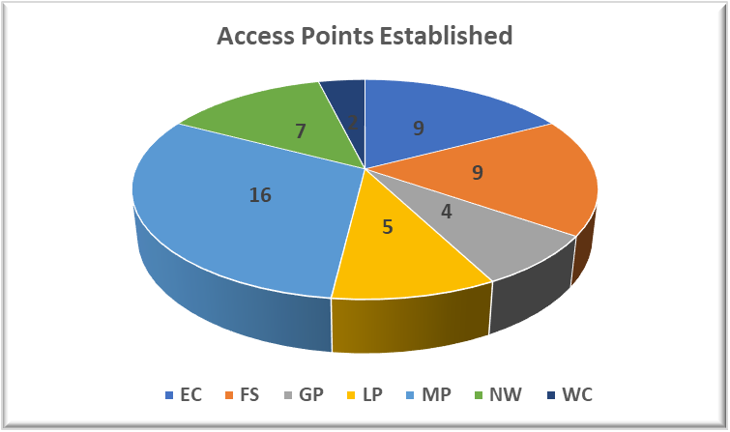

Seda will continue to expand service delivery to rural communities through various modalities whilst striking a sound balance between community needs, budget availability and collaboration with ecosystem partners.

During the 2022-23 financial year, Seda has reached 68 117 SMMEs and Co-operatives through entrepreneurship awareness sessions throughout the country. Pop-Up Markets that are hosted in collaboration with our strategic partners also assist to raise awareness and promote the services and benefits offered by Seda. Seda organised 39 Pop-Up markets in 2022-23 financial year. Following are a few recent examples:
- Seda Namakwa branch conducted their Pop-Up market from 28 February 2023 to 1 March 2023 where various clients exhibited their products and services. Eighteen (18) exhibitors were in attendance.
- Seda ZF Mgcawu branch hosted the Pop-Up Market from on 2-3 March 2023 in Upington.
- The Nkangala Branch held a Pop-up market on 17 March 2023, in Delmas, and twenty-five (25) SMMEs exhibited their products and services in partnership with Victor Khanye Local Municipality and Standard Bank.
- Seda Limpopo hosted a Pop-Up market in collaboration with the Groblersdal Mall in February 2023.
- The Mopani Branch in conjunction with the district and local municipalities hosted two (2) Pop-up markets and one (1) in Waterberg on 31 March 2023.
- Small Business Development Portfolio (DSBD, Seda and sefa), in collaboration with Exxaro, hosted a three-day mall activation at Lephalale Mall, Limpopo, from 24-26 March 2023. Twenty-two (22) local entrepreneurs from the manufacturing, arts and craft, agriculture, and service sector participated in the exhibition.
- Pop-Up markets were held in the Brits Mall with ten (10) SMMEs and Letlhabile Mall with fifteen (15) SMMEs exhibiting. Both events were held on the 31 March 2023 and ending on 1 April 2023.
During the 2022/23 financial year, Seda trained more than fifteen thousand one hundred and nineteen (15,119) SMMEs on various programmes and courses. These includes courses amongst many other Basic Business Skills, Business Start-Up 1, Cybercrimes, Hazard Analysis Critical Control Point (HACCP) Awareness, Food Safety, Quality Management System (QMS), SARS Incentives, Export Awareness, Costing, Empretec, Business Planning, Business Model Canvas, Community Public Private Partnership, Art of Pitching, Customer Care, Retail Management, Design Thinking, Green Economy, etc. Training are needs based and often presented in collaboration with our partners. Below are a few examples:

- The Seda ZFM branch conducted a 3-day Farm management training with small scale farmers in the small-town agricultural town of Keimos. The training helped by upskilling them on the management activities and responsibilities involved in running an agri-business. Basic activities involved in the agri-management process were explained by providing examples and scenarios.
- Seda Thabo Mofutsanyana Branch partnered with the Department of Correctional Services with the aim of developing a capacity program for inmates based in Bethlehem prison. The Provincial Regional Facilitator conducted self-mastery training attended by twenty-seven (27) inmates over 3 days.
- Free State Department of Economic, Small Business Development, Tourism and Environmental Affairs (DESTEA) in partnership with the Motheo TVET College hosted a Financial Symposium on 8 March 2023 in Bloemfontein. The Seda Provincial Office and Mangaung Branch, together with sefa, attended the session with other stakeholders namely, Nedbank, NEF, and the Department of Trade Industry and Competition (the dtic) to present offerings to the audience. Ten (10) Seda clients from the district exhibited their products and services.
- Seda Joburg Branch collaborated with EkasiLab from the Innovation Hub to roll out design clinic training in Soweto and Kagiso for approximately thirty (30) Small Businesses. Seda covered the cost of training and EkasiLab provided venues and catering.
- Seda Gert Sibande Branch has partnered with Coca-Cola to train fifteen (15) businesses. The training took place in February 2023. Coca-Cola offers a three(3)-meter container valued at R150 000 and a Fridge to the Spaza Shops in rural and township areas.
- The Innovation and Technology unit of the the dtic, DSBD in partnership with Seda Thabo Mofutsanyana Branch invited prospective entrepreneurs with innovative ideas from Setsoto and Dihlabeng Local Municipalities to attend the innovation workshop. The workshop was held in Bethlehem and Ficksburg (Ntsu Secondary School, Comp High School, Seda Bethlehem office and Ficksburg hall) from 14-15 March 2023. The purpose of the workshops was to unearth technologies from the communities and townships of the district, create networking platforms for technology development and commercialisation and present technology offerings of the the dtic. More than a hundred (100) participants attended the session in four (4) different venues including two high schools in Bethlehem.
Seda has an Export Orientation Course (EOC) which focuses on Export Development. These courses focus on the business with the aim of helping the business assess its export readiness. The training targets SMMEs that have the intention and the potential to enter the export business or those already involved in exports but wanted to strengthen their knowledge in this field of business.

The SheTrades programme is a partnership between the International Trade Centre (ITC), DSBD and Seda to promote Women’s Entrepreneurship. ITC SheTrades has set up a Hub in South Africa to help South African women entrepreneurs increase their international competitiveness and connect to national, regional, and global markets through the SheTradesZA Hub. The primary objective of the Hub is to connect at least 10 000 women owned businesses to markets by 2024. This is part of South Africa’s contribution to ITC's goal of connecting three million women entrepreneurs to markets by 2023.

A total of 3003 women have registered as at the end of March 2023. Through the programme, women-owned businesses will be able to:
- Connect to potential buyers, investors, suppliers, business support organizations and SheTrades partners.
- Learn skills to boost business potential through free e-learning courses, on-site workshops, and webinars.
- Receive support to attend national, regional, and international trade fairs.
- Get chances to participate in B2B meetings.
- Access to investment opportunities.
- Increased visibility and larger network in international markets.

Seda has also forged three key skills development partnerships namely:
- A 3-year partnership with the National Skills Fund (NSF) to benefit 14 000 beneficiaries for a total budget of R 592 275 000. The aim of the project is to recruit unemployed graduates with Accounting and Business Management qualifications to be trained on New Venture Creation, Coaching, and Mentorship Programme to enhance their skills to provide support to Micro Enterprises. Seda will use coaching as an innovative methodology to facilitate and reinforce learning and development support to Micro Enterprises and the unemployed graduates will be trained on new venture creation as well as business coaching to enable them to transfer skills & knowledge to Micro Enterprise owners.
- Seda and W&R Seta signed an agreement to support one thousand (1000) Tuckshops, General Dealers to the value of R 9 975 000.
- In 2021, DSBD, Seda and Merseta signed Agreement for Merseta to release a discretionary grant to Seda to the value of R 50 million. The funding will be provided in phased approach over a 3-year period. The purpose is to train Small Enterprise in the Automotive Trade Sector as well as facilitate Artisan Recognition of Prior Learning (ARPL).

In addition to the above, Seda through its Learning Academy has also developed different training programmes. These programmes are credit bearing and accredited by the Services Seta. Quality training aims to assist organisations of all types to implement and operate the QMS to increase effectiveness, consistency, and customer satisfaction, explain the benefits of implementing QMS and understand the quality, management principles. Whilst Food safety introduces Food Safety, Understand Pre-Requisite programme, HACCP and HACCP principles and Implementing a Food Safety Management System (SANS 22000:2019.).

Seda has an Entrepreneurship in Schools Programme that encourages learners to consider entrepreneurship as an alternative career to employment. The main objective of the programme is:
- To influence the mindset of learners by encouraging them to become job creators instead of job seekers once they leave the schooling system.
- To equip learners with entrepreneurial knowledge and skills needed to start and manage their businesses; and
- To improve entrepreneurial activity amongst the learners and educators.

Seda is also in partnership with the United Nations Conference on Trade & Development’s (UNCTAD)
Division of Investment and Enterprise United Nation’s Empretec training Programme.
- Empretec is a six (6) day programme aimed based on a unique Harvard University methodology focusing on behavioural approach to entrepreneurship.
- The programme is interactive, experience and self-assessment based and takes 25-30 participants per workshop. Participants learn by doing.
- Participants on this programme receive an UNCTAD endorsed certificate.
- Programme develops Personal Entrepreneurial Competencies (PECs) such as opportunity seeking, persistence, goal setting, risk taking, fulfilling commitments, planning etc. for participants.

Seda has a dedicated programme, The Basic Entrepreneurship Skills Development (BESD) which was jointly developed by Seda and German Federal Ministry for Economic Cooperation and Development via Deutsche Gesellschaft für Internationale Zusammenarbeit (GIZ) since 2012. GIZ left the programme in December 2016. The programme is funded by the National Skills Fund for an amount of R84 million. The BESD approach utilises coaching as an innovative methodology to facilitate and reinforce learning and development support to emerging entrepreneurs. A total of 260 undergraduates and 1998 Emerging Entrepreneurs successfully completed the training initiative.

