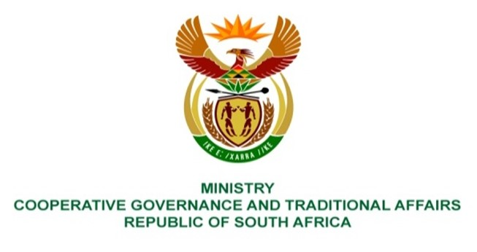

NATIONAL ASSEMBLY
QUESTION FOR WRITTEN REPLY

QUESTION NUMBER 2124
DATE OF PUBLICATION: 27 MAY 2022

QUESTION:

2124. Mr H C C Krüger (DA) to ask the Minister of Cooperative Governance and Traditional Affairs:
- What were the findings of the report from Analytical Forensic Investigation Services in the Emalahleni Local Municipality in terms of section 106(1)(B) of the Local Government: Municipal Systems Act, Act 32 of 2000;
- whether the specified report has been tabled in the council; if not, on what date will the report be tabled before the council; if so, on what date;
- whether anyone implicated in the report has been criminally charged based on the findings of the report; if not, why not; if so, what are the full details of the (a) charges, (b) dates on which charges were laid, (c) case numbers, (d) police stations where the charges were laid and (e) implicated persons? NW2532E

REPLY:

The below response was provided by the Mpumalanga province:
- The Emalahleni municipality section 106 investigation report has not yet been officially released by the provincial government. The report is yet to be tabled before the provincial executive council and then be tabled before the municipal council for them to adopt and develop an action plan to respond to the findings. It would be premature to make any pronouncements on the contents of the report until it is tabled at both the executive council and the municipal council.
- The report will be tabled before the municipal council after it has been tabled before the provincial executive council.
(3) As indicated above the report has not yet been officially released by the provincial government.
(a) Not applicable.
(b) Not applicable.
(c) Not applicable.
(d) Not applicable.
(e) Not applicable.

