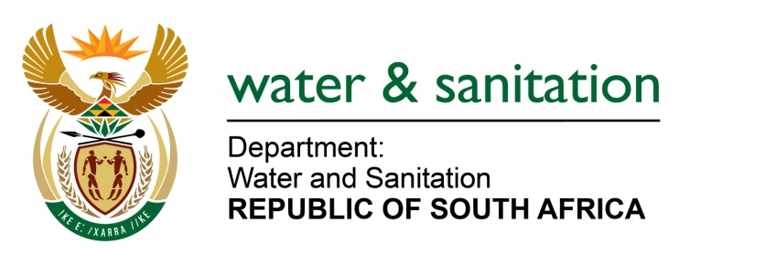

NATIONAL ASSEMBLY

FOR WRITTEN REPLY

QUESTION NO 2122

DATE OF PUBLICATION IN INTERNAL QUESTION PAPER: 23 SEPTEMBER 2016
(INTERNAL QUESTION PAPER NO. 29)

2122. Mr T Rawula (EFF) to ask the Minister of Water and Sanitation:

By what date is she going to eradicate the bucket system in Grave Yard and Marikana informal settlements in the North West? NW2434E
---00O00---

REPLY:

The Bucket Eradication Programme is focusing on the eradication of bucket toilets in FORMAL areas and not informal areas. The North West Department of Human Settlement together with the relevant municipality should put measures in place to address the upgrading or the relocation of the informal settlement.
---00O00---

