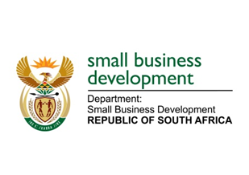
NATIONAL ASSEMBLY
QUESTION FOR ORAL REPLY
DUE TO PARLIAMENT: FRIDAY, 16 JUNE 2023

“2121. Mr M Bagraim (DA) to ask the Minister of Small Business Development:
With reference to the assertion of the President of the Republic, Mr M C Ramaphosa, in the State of the Nation Address on 9 February 2023 that small- and medium-sized enterprises (SMMEs), cooperatives and informal businesses will drive growth and create jobs in the Republic’s ailing economy, (a) what are the reasons that she has not yet taken any steps to reduce regulatory impediments for SMMEs and cooperatives to make it easier for entrepreneurs to start businesses and (b) by what date does she intend to introduce amending legislation in this regard in the National Assembly?” NW2406E

REPLY:
I have been advised that:
- In order to take steps towards reducing the regulatory impediments for SMMEs and Co-operatives, the DSBD in partnership with key stakeholders like South African Local Government Association (SALGA), the Department of Trade Industry and Competition (the dtic), Foundations and Think Tanks embarked on the following processes:
- Conducted extensive research and rapid literature review to- identify key regulatory impediments, analyse them and design best methods and interventions, as well as strategies that could be adopted to address those impediments.
- Through this research, the DSBD has identified 29 major regulatory barriers that this project will focus on the implementation of specific remedies, options, and reforms at National, Provincial and Local levels of government in the coming financial years.
- The findings of the research have been piloted in selected municipalities to test their efficacy.
- These findings were also used as a resource to support the work of the Red Tape Reduction Committee at the Presidency.

- In the 2021-22 financial year period the DSBD started the process of reviewing the Businesses Act (No.71) of 1991 and the Licensing of Business Bill 2013 and will be introducing the Businesses Amendment Bill to Cabinet in the second quarter.

